Psy406 (educational Psychology)
Quizzes/sujective Mega File
Prepared by
innocent Mishii Brave Heart Misbah Shaukat

Quiz file

- Hitting, kicking, spitting and pushing are signs of __________. Confidence

Courage Assertiveness Aggression
- Who discover the theory of relativity?
Skinner

Pavlov

Maxwell

Einstein
- INTASC is an abbreviation of ____________________. Interstate New Teacher Assessment & Support Consortium Interstate Novel Teacher Assessment & Support Consortium Interstate New Teacher Assessment & Support Conglomerate Interstate New Teacher Assessment & Support Corporation
- Vygotsky, a Russian psychologist was born in which of the following year?

1796

1777

1888
1896

- Which part of the brain deals with spatial and visual processing? Parietal hemisphere

Frontal hemisphere Right hemisphere Left hemisphere
- During ____________ aggression, a person secures a reward without hurting others.

Hostile Relational Exert Instrumental

- Identify the stage in which child learn new skills and when unable to perform, feels inferior?
Autonomy versus Doubt/Shame Stage

Identity versus Role Confusion Stage

Industry versus Inferiority Stage
Generatively versus Stagnation Stage

- Aslam is unable to comprehend; what he has read from his English textbook. He exhibits

__________________ error.

Sentence

Symbol

Word

Comprehension
- Ali, 16-years old boy is interested to know about the physiological changes during adolescence period. He is more likely at ___________ stage.
Trust vs. Mistrust

Intimacy vs. Isolation

Integrity vs. Despair

Identity vs. Role confusion
- “Interstate New Teacher Assessment and Support Consortium” is an examination body of:

United Kingdom

Germany

Canada

United States of America
- A teacher in the class nominates some of the students as “more intelligent” and the other ones as “less intelligent”. She is more likely to use ______________ phenomenon.

Stigmatization

Labeling
Self-fulfilling prophecy

Grouping

- Handshake with opposite sex is an acceptable behavior in European culture and not acceptable in Pakistan. This is an example of ____________.

Reflective culture

Friendly culture

Cultural conflict
Cultural compatibility

- Ahmed finds difficulty in pronouncing a word; he is more likely to exhibit ____________

disorder.

Learning

Language

Articulation
Speech

- Ali refuses to read when his teacher asks him to read. This clearly indicates that he has: Bad writing habits

Bad reading habits Comprehension error Word recognition error
- ___________disabilities are found in students when they face difficulty in reading, writing and mathematics.

Psychological

Physical

Cognitive
Learning

- _____________ refers to a person’s psychological sense of being either male or female. Gender Identity
Gender Role

Gender Discrimination

Gender Prejudice

- Ajmal finds difficulty in communicating his own thoughts with his friends. He is more likely to exhibit __________________ disorder.

Learning

Language

Articulation

Speech

- ________________is defined as values,norms and traditions that guide and determine the behavior of a group of people.

Tradition

Culture
Custom

Nation

- _______________ consists of the behaviors, attitudes and personality traits that a given culture designates as either “masculine” or “feminine”.

Gender Identity
Gender Role

Gender Discrimination

Gender Prejudice

- Sindhi ajrak is an example of which type of culture? Irrelevant

Relevant Non material Material

- ______________ is a term used to categorize the students on the basis of their academic achievements.

Tracking
Chasing

Pursuing

Trailing

- ____________is a prediction that comes out to be true. Self-criteria

Self-judgment Self esteem

Self-fulfilling prophecy

- WALLED city project is an attempt to save the _____________ culture of Lahore. Reflective

Conflict Non material Material
- English language accent varies from European and American states. This is referred to as: Bilingualism

Commonality

Monolinguals

Dialects
- These are the factors which affect the academic success of a child, EXCEPT: Charismatic attitude
Peer influence Poverty

Peer Influences

- Which of the following type of culture expresses in the form of language and customs? Material

Non-material
Physical

Solid

- ____________ is a negative label which describes an individual in uncomplimentary manner.

Cheating

Stigma

Grouping

Classifying

- The ability to acquire knowledge and possible utility of that knowledge in order to solve the problems is known as:

Attitude

Behavior

Traits

Intelligence
- _____________ refers to a person’s psychological sense of being either male or female.

Gender Identity
Gender Role

Gender Discrimination

Gender Prejudice

- _______________ consists of the behaviors, attitudes and personality traits that a given culture designates as either “masculine” or “feminine”.

Gender Identity
Gender Role

Gender Discrimination

Gender Prejudice

- Afifa’s teacher gives her a token as she scores good grades in the exams. She purchases a bottle while utilizing that token. Her teacher is more likely to use ___________.

Reinforcement

Shaping

Punishment

Token Economy
- Token reinforcement is NOT suitable in which of the following conditions?

To manipulate others
To control behavior

To encourage students

To motivate students

- Bandura believed that human functioning is a product of the mutual interaction of environment, person, and __________.

Behavior
Cognition

Learning

Heredity

- Which of the following is NOT an important element of vicarious learning?

Apprehension
Production

Retention

Attention

- Which of the following behavioral technique is involved in reinforcing successively closer approximations to a behavior until the occurrence of a correct behavior?

Reinforcement
Chaining

Prompting

Shaping

- Which of the following memory represents the relatively long lasting storage of information?

Sensory

Short-term

Long-term
Episodic

- Who proposed social learning theory?

Albert Bandura
Thorndike

Pavlov

Skinner

- What is the atomic weight of gold?

156.922

178.993

199.666

196.967
- Which of the following reinforcement schedule is operated when an individual is reinforced after every desired response?

Ratio
Intermittent

Interval

Continuous

- In the process of _____________ analysis, we give a meaning to the stimulus.

Processing

Feature
Article

Critique

- Which of the following metacognitive skill may involve in deciding; how much time to be given to a certain task?

Monitoring

Evaluating

Analyzing

Planning

- Which of the following function of memory is involved; when we recall the information, whenever it is required?

Encoding

Storage

Retrieval
Rehearsal

- Identify the correct sequence of stages of memory. Iconic memory, Sensory memory, short term memory

Sensory memory, Long term memory, Short term memory Long term memory, Sensory memory, short term memory Sensory memory, short term memory, long term memory
- If you wants to teach your child to "play" the violin , you should use: Punishment

Self-motivation Negative reinforcement Shaping
- A ___________ is a cognitive framework that helps in organizing and interpreting information. Script

Schema Event schema Metacognition
- ______________________ is a technique in which rewards are given in the form of tokens as a result of some desirable behavior.

Token cards Token pokers Token chips

Token Economy
- A teacher praises her student by giving a star on the note book as student performs well in the class; she is more likely to use______________.

Shaping

Reinforcement
Extinction

Association

- Sensation + Meaning = ____________________.

Learning

Perception
Sensation

Memory

- Fahad comes to know that his favorite restaurant will remain open till 6pm. Which of the following memory may help Fahad to remember the opening timings?

Semantic

Procedural

Declarative
Short-term

- Ali has negative self-concept and considers that he is a bad person who never performs well in class. This is an example of

First-wave Constructivism---Individual Contribution
Second Wave Constructivism--Social Contribution

Third WSecond Wave Constructivismave ConstructivismFirst Wave Constructivism

- My English teacher is skinny and my last term English teacher was also skinny so I have come to know that all English teachers are skinny. This is an example of what?

Expository reasoning

Discovery reasoning

Deductive reasoning
Inductive reasoning

- Nainna is competing in GRE test for full bright scholarship. This is an example of which type of motivation?

Internal

Superficial

Middle

External

- These all are the ingredients that should be kept in mind while summarizing the material, EXCEPT:

It should be lengthy
It should be too the point

It should be clear

It should be short

- ______________ are commonly used in domain-specific problem solving strategy, in which a problem tends to be solved by using step by step procedure.

General

Domain-specific

Heuristics

Algorithms
- Ali is a taxi driver and now he is transferring his learning for driving the truck; this is known as what?

Challenging the knowledge

Exerting transfer of knowledge

High transfer of knowledge

Low transfer of knowledge

- When a less experienced student is taught by a more experienced teacher, this phenomenon refers to as ___________

Instructional conversation

Problem-based learning

Cognitive apprenticeship
Inquiry learning

- If a student learns different mathematical principles and then use that information in comprehending the physics laws is known as:

Remembering

Declarative memory
Memorization

Transfer of knowledge

- Identify the method in which a realistic problem has been discussed in class and students have to give the possible solutions?

Cognitive Apprenticeship

Instructional Learning

Problem Based Learning
Inquiry Learning

- If an individual learns new experience with the help of observational learning, he or she must

Reward after doing wrong action

Be rewarded immediately after performing an action
Rewarded for every third instance of a behavior

Imitate the behavior of a model

- Which of the following refers to the main central area of the physical environment of the classroom in which students interact with each other?

Interest area

Personal territory

Personal ground

Aptitude area

- All of the following factors may affect self-regulation EXCEPT:

Knowledge about oneself

Demotivation
Will power

Family influence

- A teacher makes sure that at the end of the class; draw a square with a pencil on a plain paper. This is an example of which type of objective?

Class

Cognitive

Behavioral
Instructional

- The middle score in a series of score is called what?

Percentile

Median
Mode

Mean

- Pakistan is a ___________ society.

Tricultural

Bicultural

Unicultural

Multicultural
- ____________intelligence refers the ability to process emotional information in an effective manner.

Academic

Spiritual

Emotional
Linguistic

- What is meant by perceiving emotions?

Highlighting emotions

Discussing emotions

Explaining emotions

Recognizing emotions
- Which of the following tests are conducted under uniform conditions and providing scores according to uniform procedures?

Non-standardized

Semi-standardized

Standardized
Sub-standardized

- Which of the following is NOT an aspect of divergent thinking?

Review
Flexibility

Fluency

Originality

- A teacher asks the student to identify the most frequently occurring numbers among the series of numbers. Which of the following measurement has been discussed?

Median

Mean

Mode
Standard deviation

Quiz #1:

. Which of the following method is directed towards the study of individual behavior?
Select correct option:
Experimental
Differential
Observational
Clinical
. Observation and recording of behavioral events under controlled conditions is known as:
Select correct option:
Introspection
Experimentation
Normative survey method
Psychoanalytic method
. Edward Tolman is one of the founders of:
Select correct option:
Behaviorism
Cognitive Psychology
Gestalt psychology
Psychoanalysis
. In the early days of evolution of psychology behavior was studied through the method of inner observation, called ____________.
Select correct option:
Observation
Analysis
Introspection
Scrutiny
. There are three classical psycho-physical methods devised by Fechner, which of the following is not included in it?
Select correct option:
The method of minimal changes
The method of constant stimuli
The method of mean error
The method of mode error
. Which of the following is relatively a prevalent approach in contemporary psychology, which studies how we feel in altered states of awareness?
Select correct option:
Transpersonal psychology
Cognitive Psychology
Humanistic Psychology
Psychoanalytic
. The control of conditions and variables is the key factor of ____________ method.
Select correct option:
Differential
Introspection
Observation
Experimental
. Who set up the first American laboratory for psychology?
Select correct option:
William James
Hermann Ebbinghaus
Granville Stanley Hall
Leona Tyler
. Connectionist theories belong to which of following school of thought?
Select correct option:
Cognitive psychology
Psychoanalysis
Behaviorism
Gestalt psychology
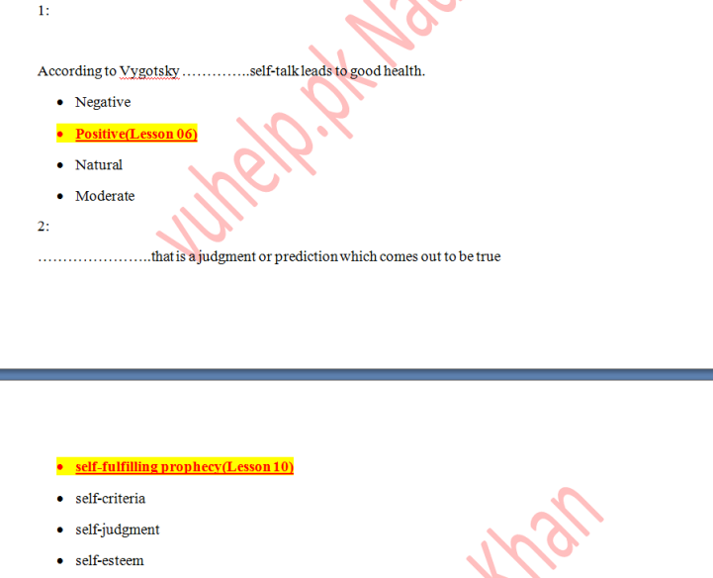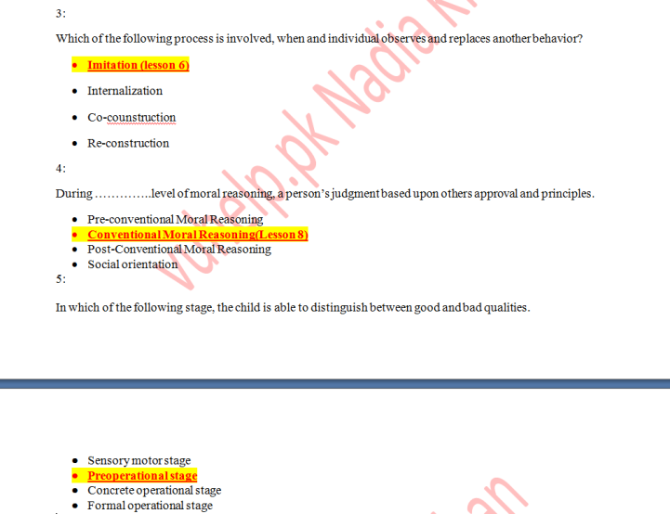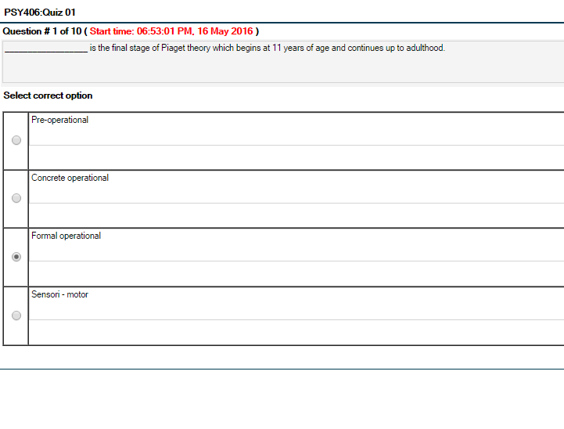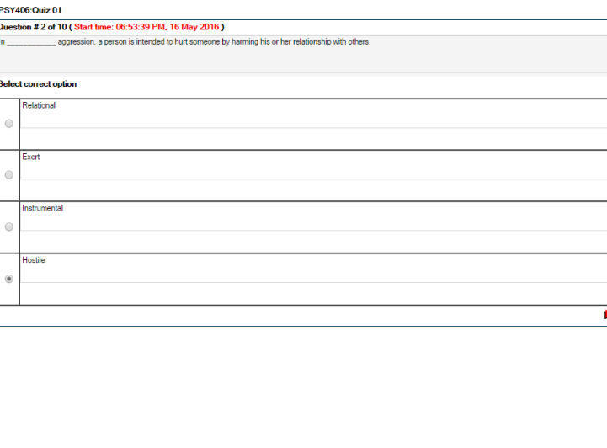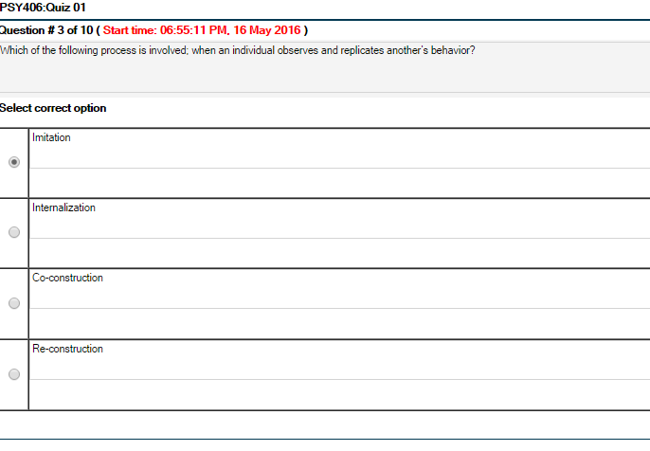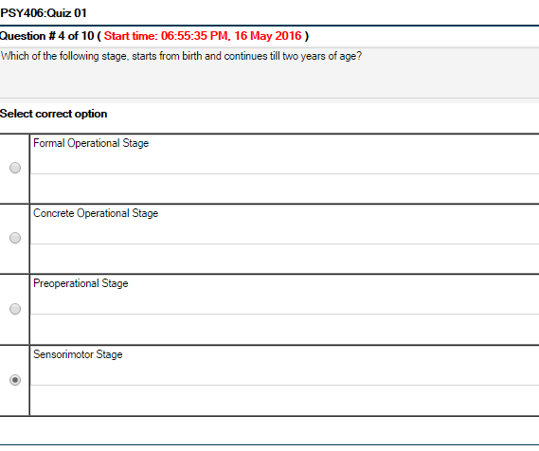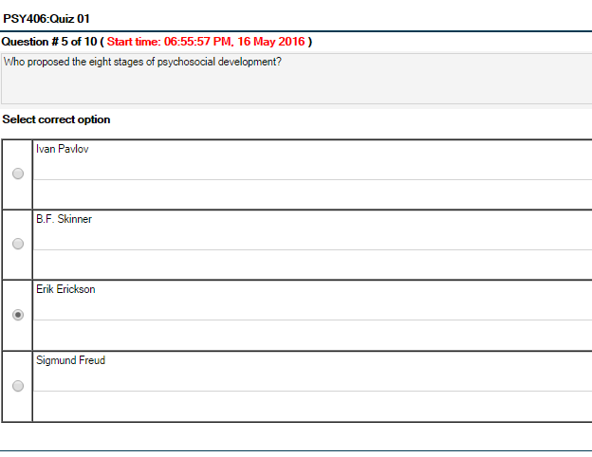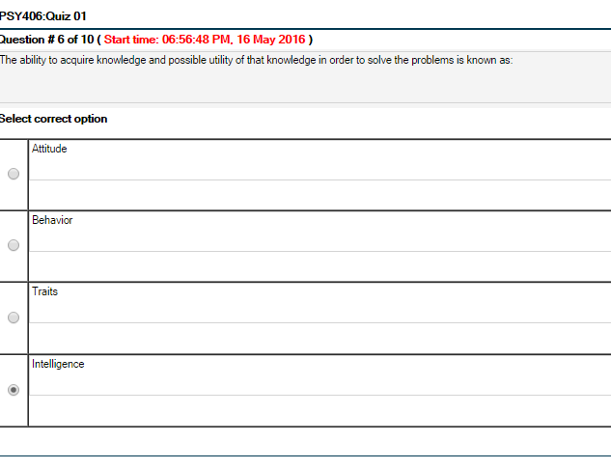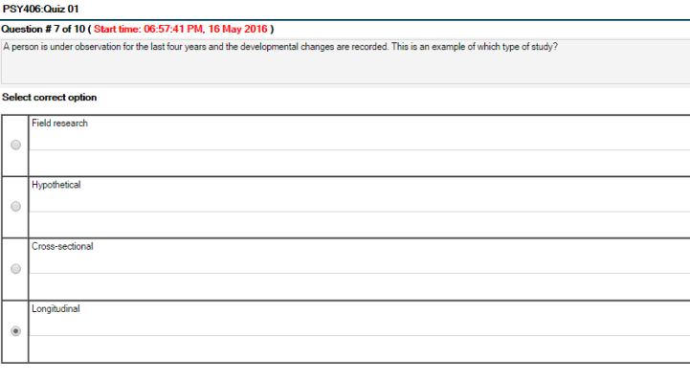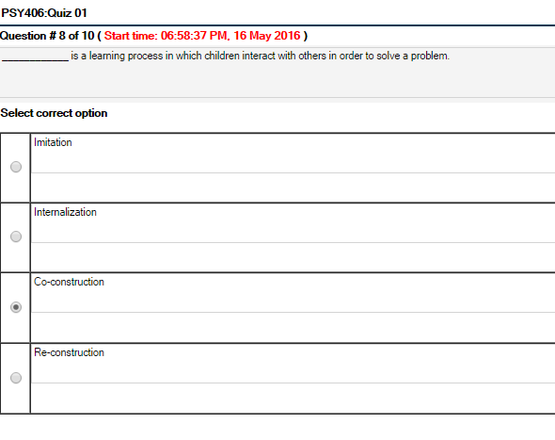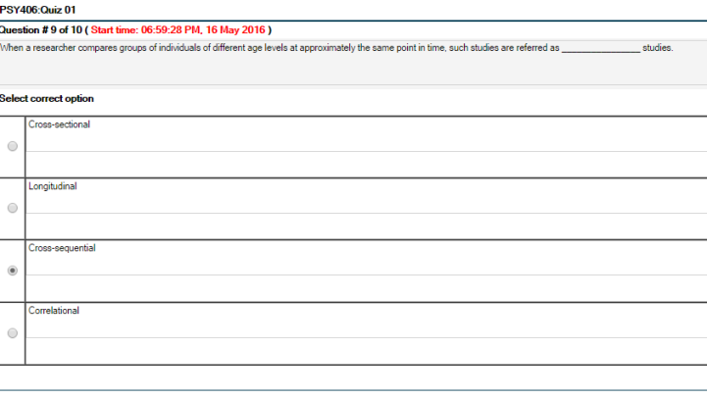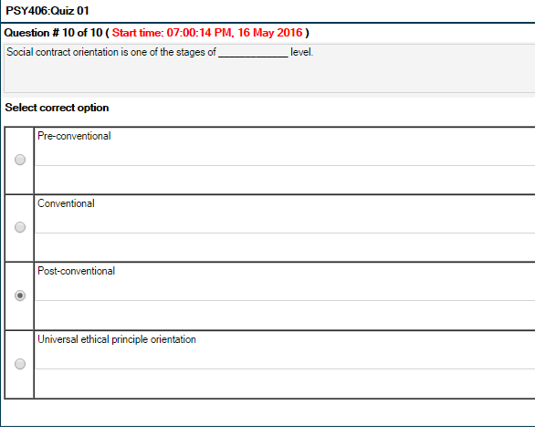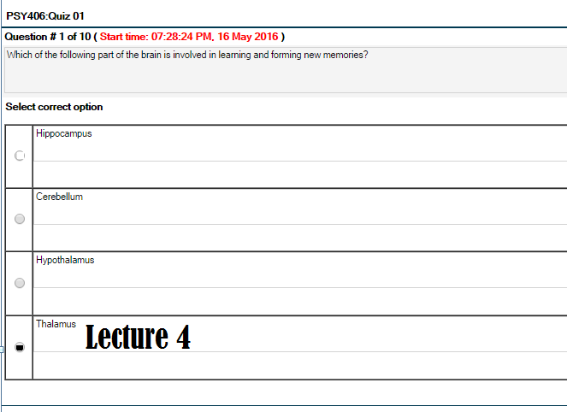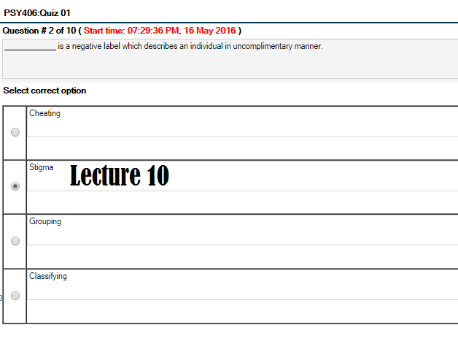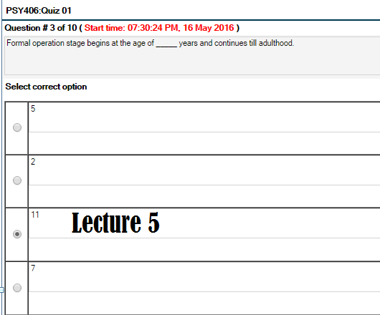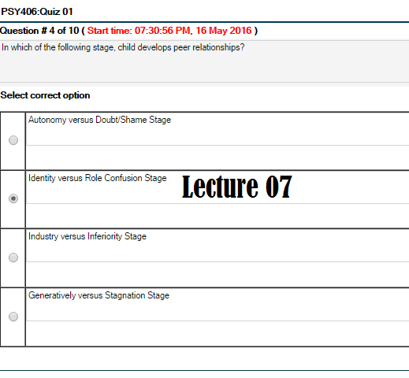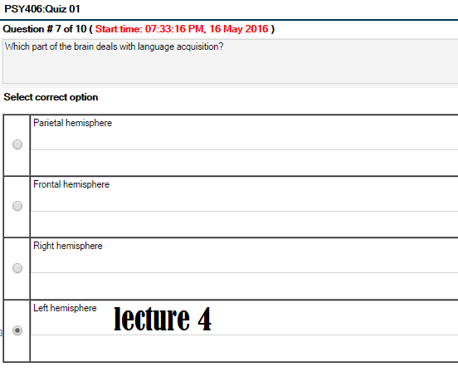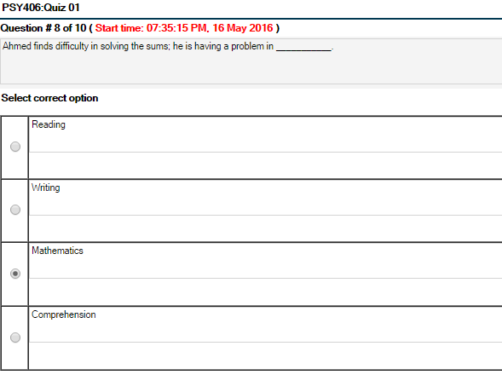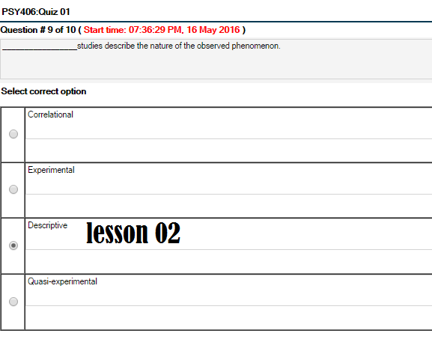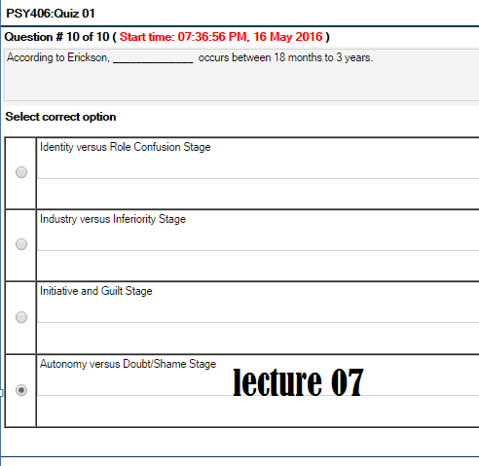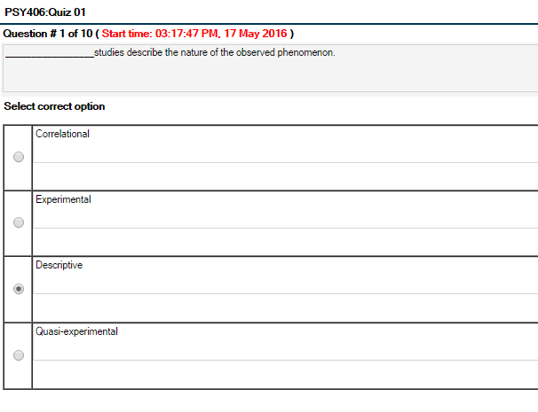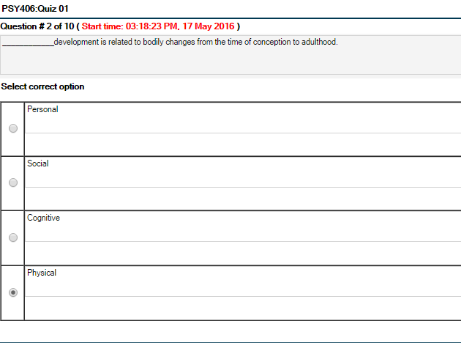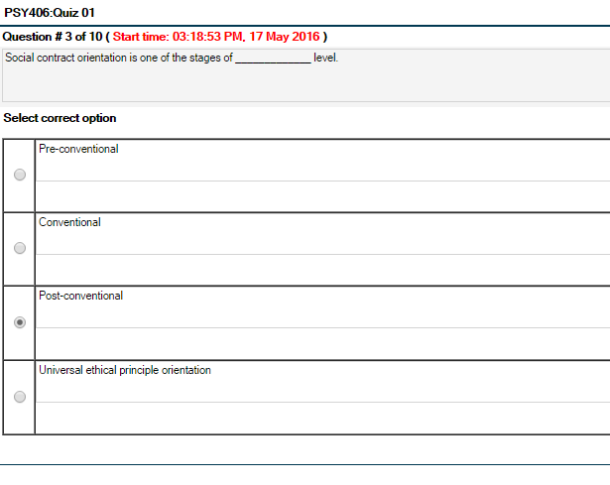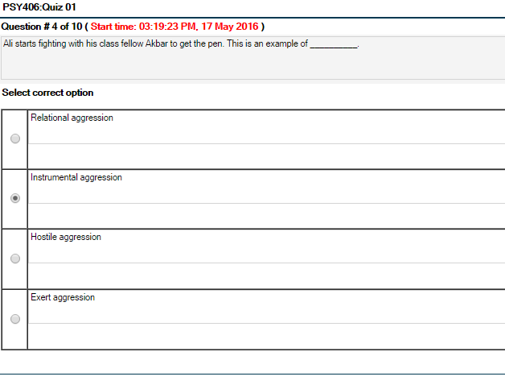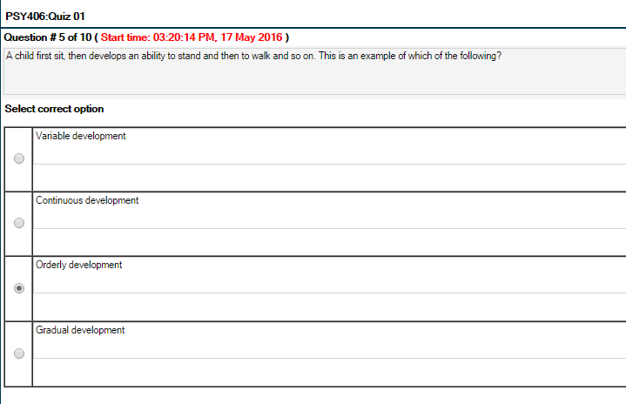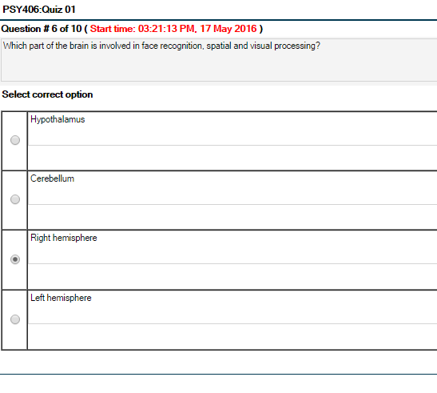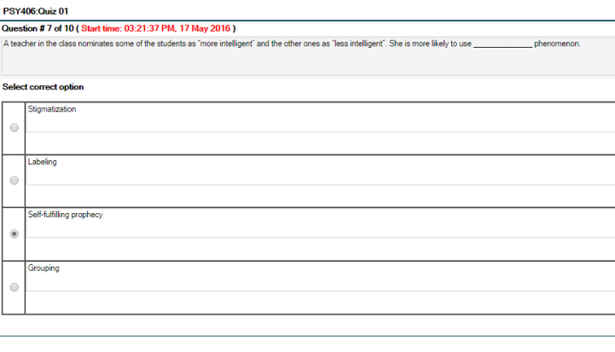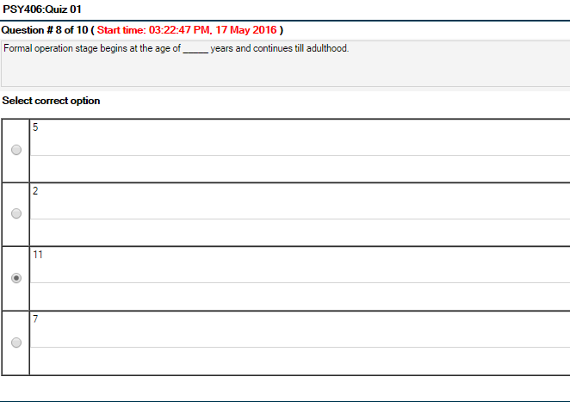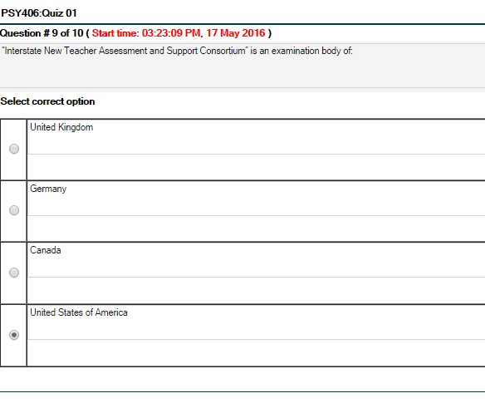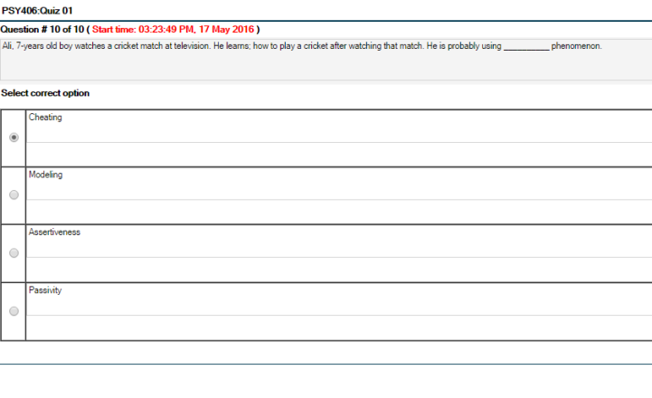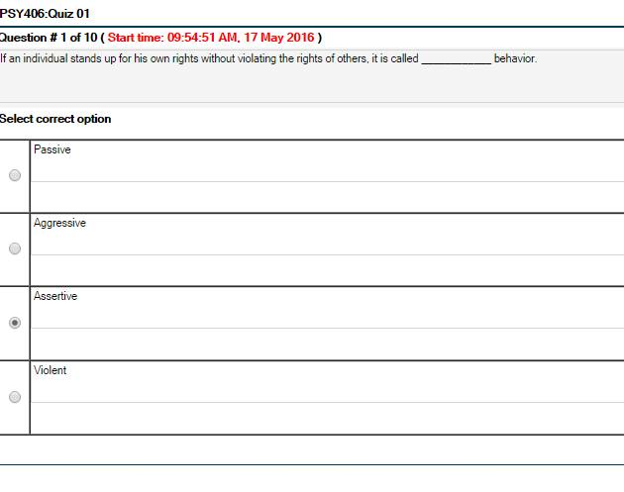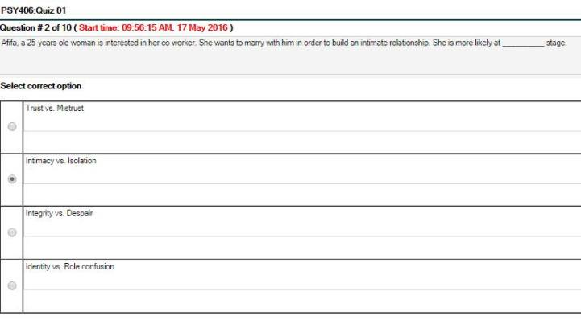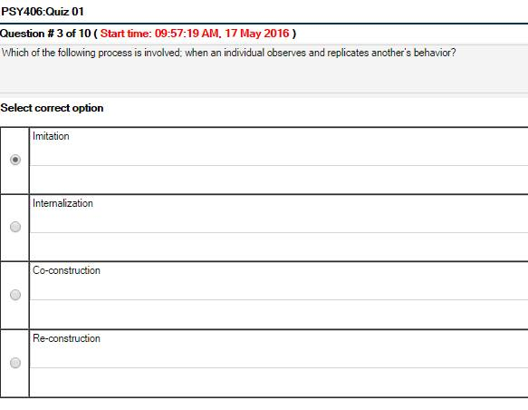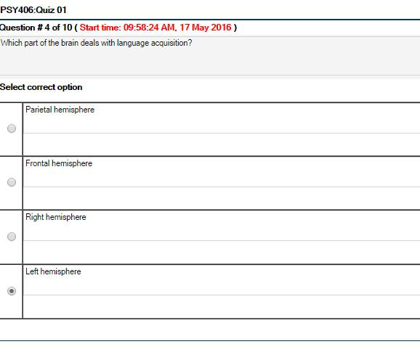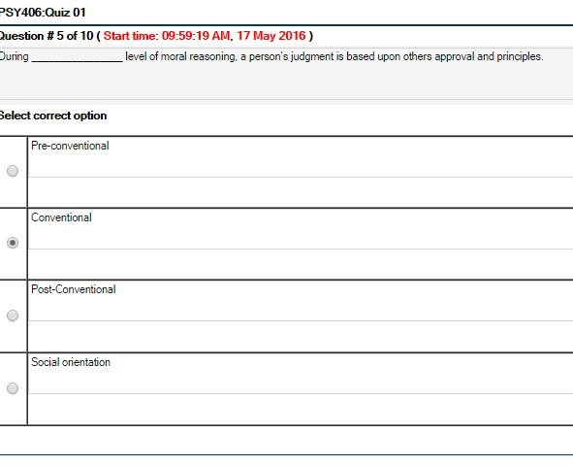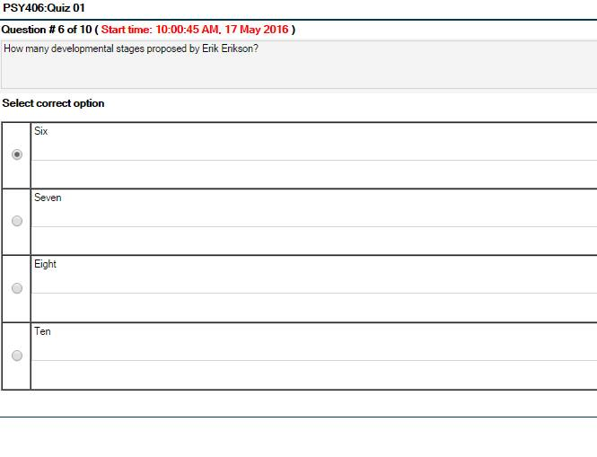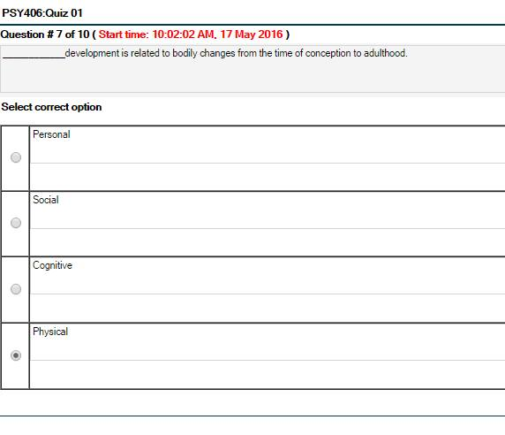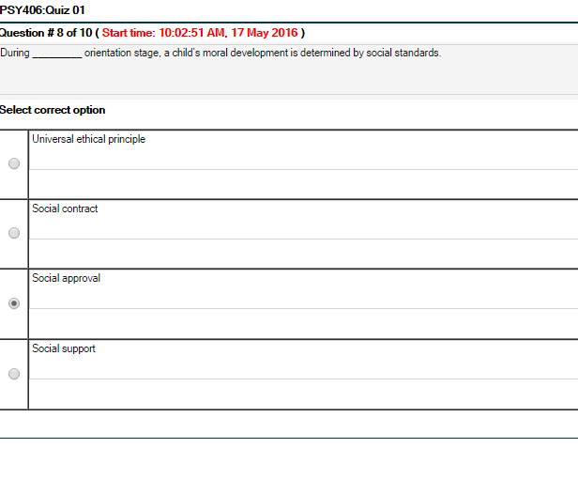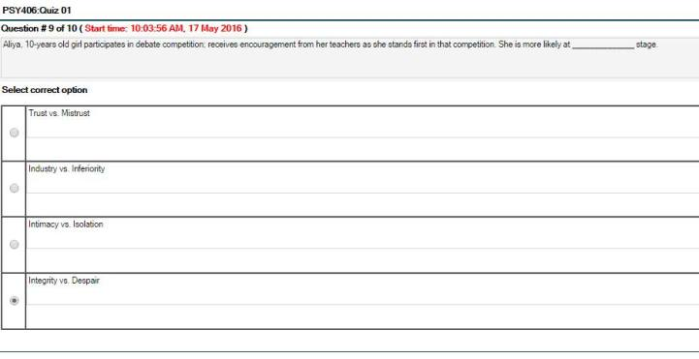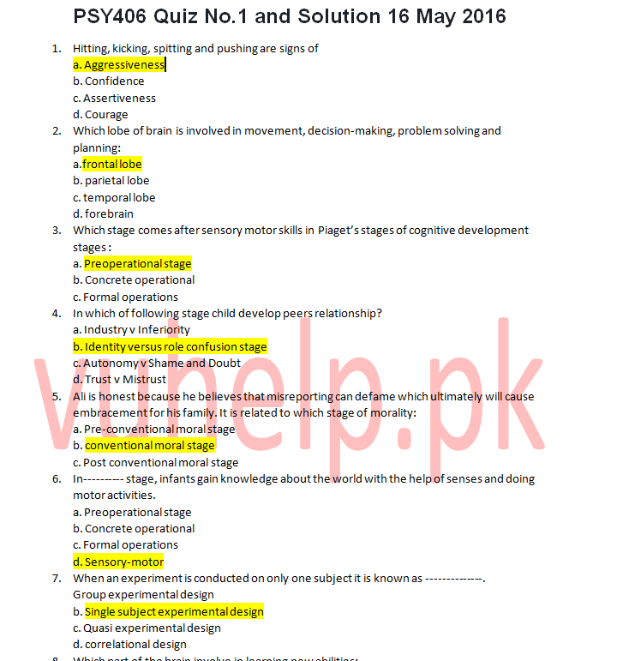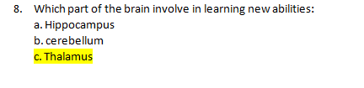
Quiz #2:

. Carl Rogers, Abraham Maslow and Rollo May are some of the eminent workers of ____________ School of psychology.
Select correct option:
Humanist
Behaviorism
Gestalt
Transpersonal
. Which of the following is the concentration of consciousness upon one subject rather than upon another?
Select correct option:
Thinking
Problem-solving
Attention
Reasoning
. In designs involving rotation method we may obtain half measures for condition A, all the measures for condition B and then the other half of the measures for condition A. This technique is sometimes called:
Select correct option:
BBA
ABBA
AAB
AABB
. A book entitled “The Measurement of Intelligence” was written by ______________ during World War I.
Select correct option:
Lewis Madison Terman
Leona Tyler
Thorndike
John Dewey
. Which of the following method is based on individual differences, and it is also named as Normative Survey method?
Select correct option:
Clinical method
Differential method
Experimental method
Naturalistic observation
. Drives are influenced and guided by:
Select correct option:
Incentives
Praise
Bonus and rewards
All of the given options
. In Erickson’s stages of psychosocial development “initiative” refers to:
Select correct option:
Developmental crisis
Independence
Eagerness to engage in productive work
Willingness to begin new activities
. Connectionist theories belong to which of following school of thought?
Select correct option:
Cognitive psychology
Psychoanalysis
Behaviorism
Gestalt psychology
. In the early days of evolution of psychology behavior was studied through the method of inner observation, called ____________.
Select correct option:
Observation
Analysis
Introspection
Scrutiny
. In Piaget’s cognitive developmental stages, the stage after Sensorimotor is called:
Select correct option:
Preoperational
Formal operational
Concrete operational
Operational

Quiz 2012

Question # 1 of 10
Who set up the first American laboratory for psychology?
Select correct option:

- Granville Stanley Hall

Question # 2 of 10
Educational psychology is a branch of psychology which deals with teaching and learning, this explanation was given by a prominent psychologist named _________.
Select correct option:

- skinner

Question # 3 of 10
Connectionist theories belong to which of following school of thought?
Select correct option:
- Gestalt psychology
Question # 4 of 10
Which of the following method is directed towards the study of individual behavior?
Select correct option:
- Clinical
Question # 5 of 10
A prominent pioneer of educational psychology ____________ was awarded the doctorate for his classic thesis “Animal Intelligence”.
Select correct option:
- Thorndike
Question # 6 of 10
Who among the following psychologists devised his own tests to measure the mental ability of his students and also measured the least noticeable difference in weight?
Select correct option:

- J. Cattel
Question # 7 of 10
Carl Rogers, Abraham Maslow and Rollo May are some of the eminent workers of ____________ school of psychology.
Select correct option:
- Humanist
Question # 8 of 10
Observation and recording of behavioral events under controlled conditions is known as:
Select correct option:

- Experimentation
Question # 9 of 10
In designs involving rotation method we may obtain half measures for condition A, all the measures for condition B and then the other half of the measures for condition A. This technique is sometimes called:
Select correct option:
- ABBA

Question # 10 of 10
Which of the following method is based on individual differences, and it is also named as Normative Survey method?
Select correct option:
- Differential method

Quiz #1
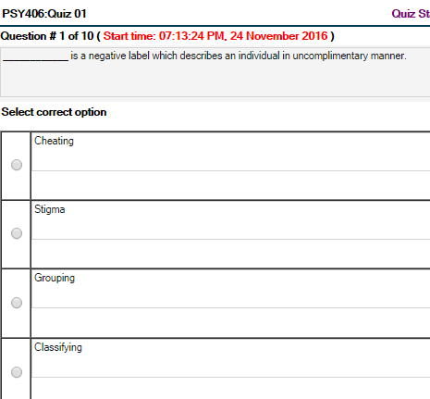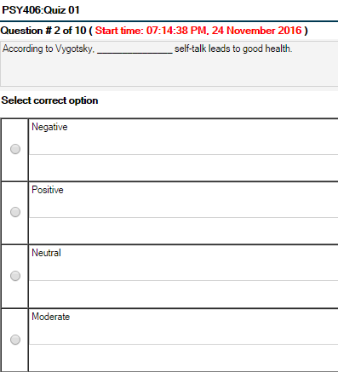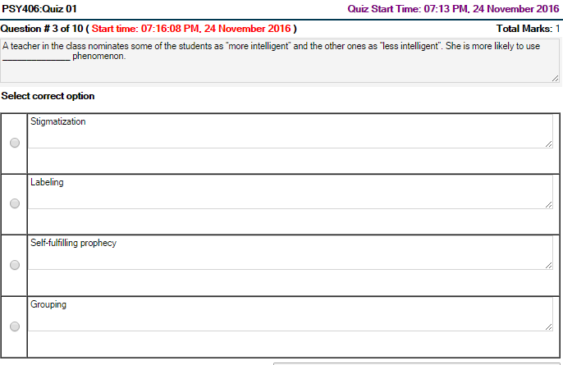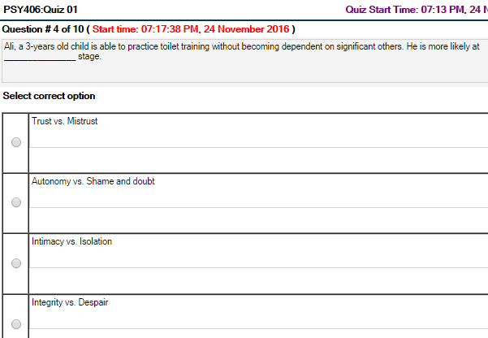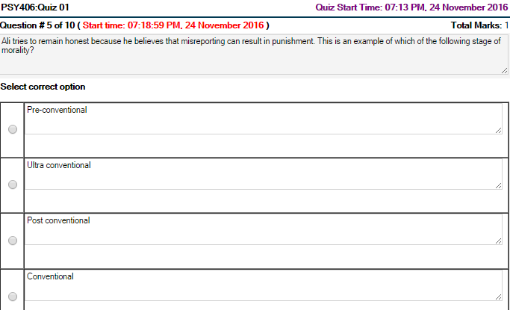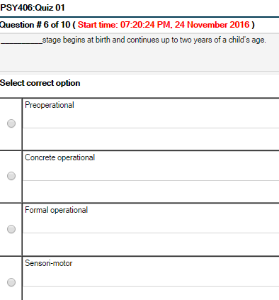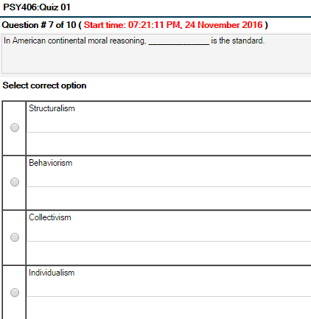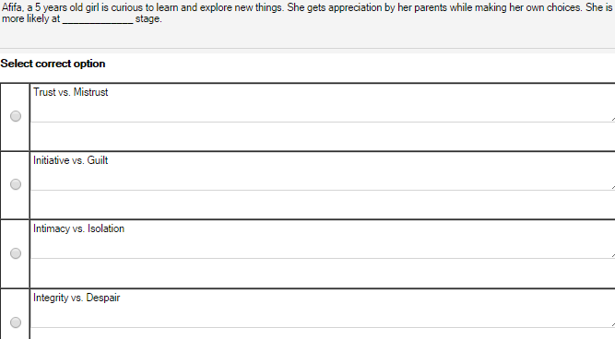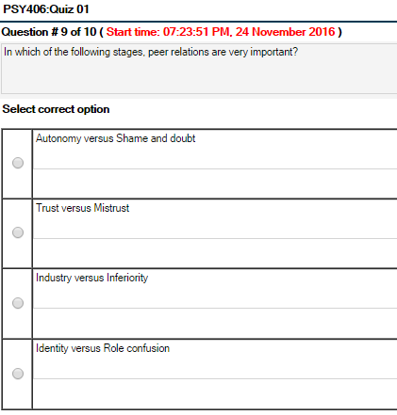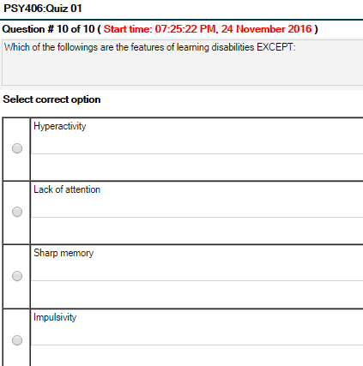
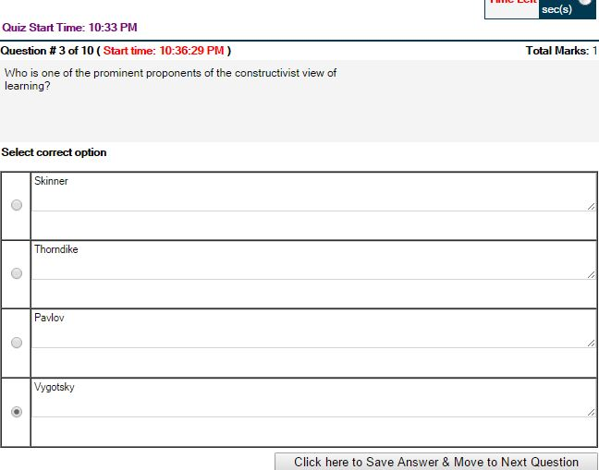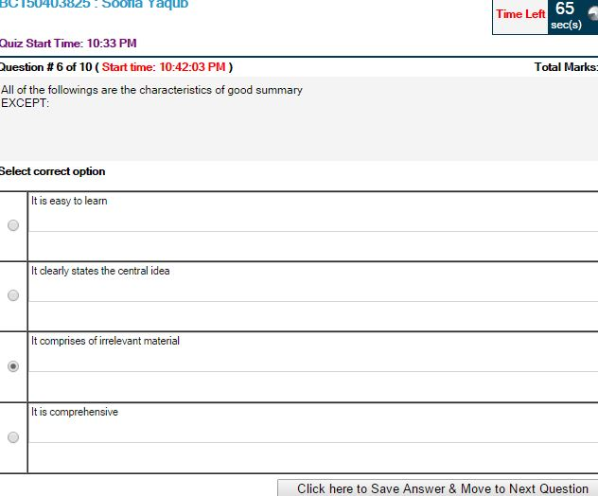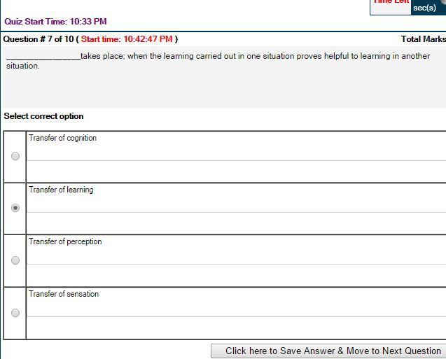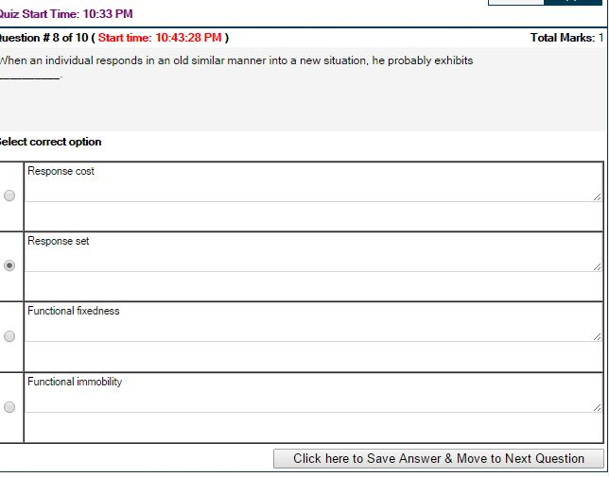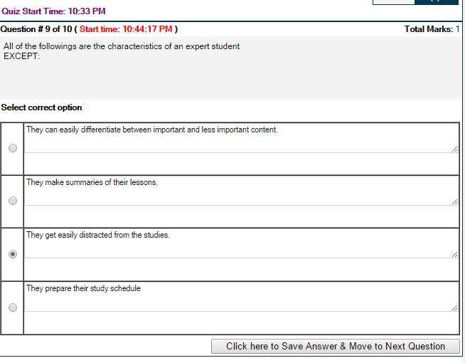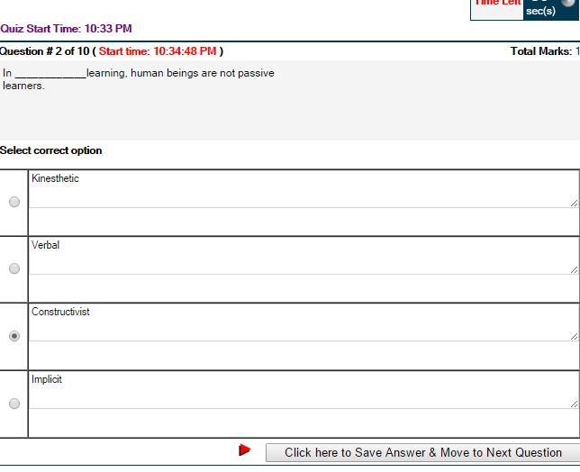

Quiz#2
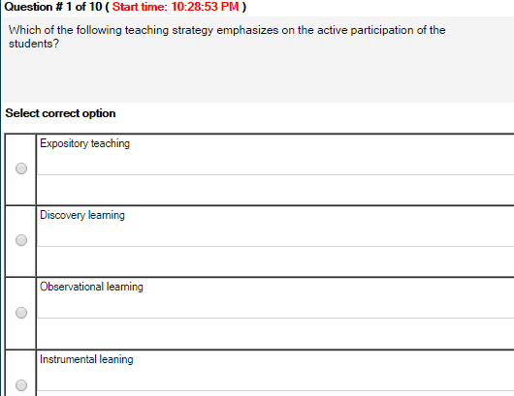
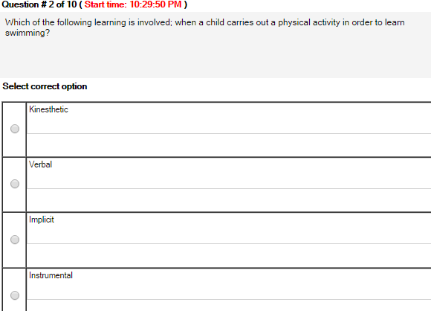
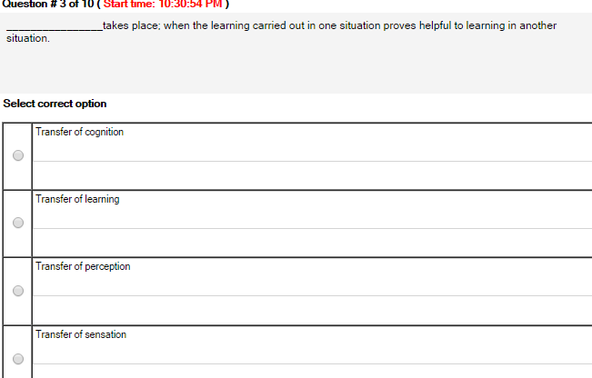
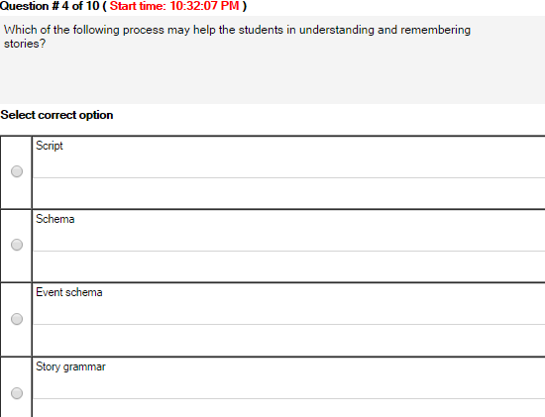

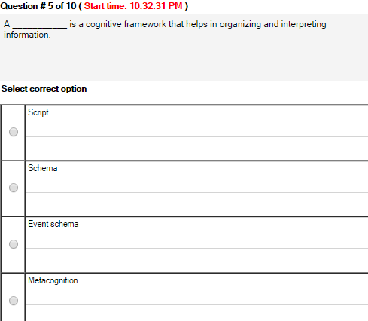
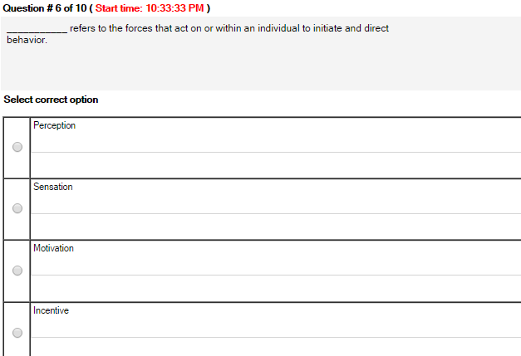
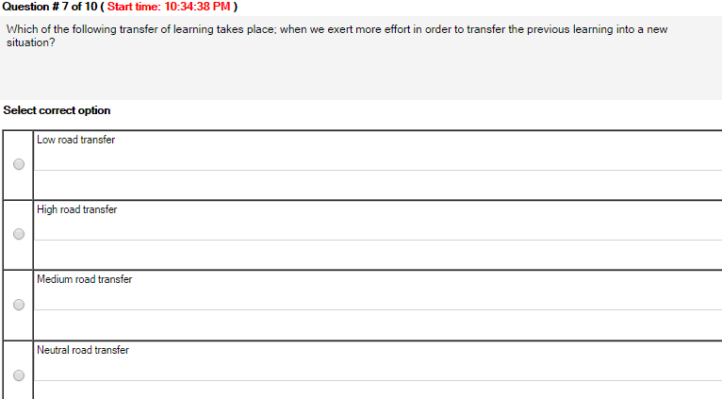
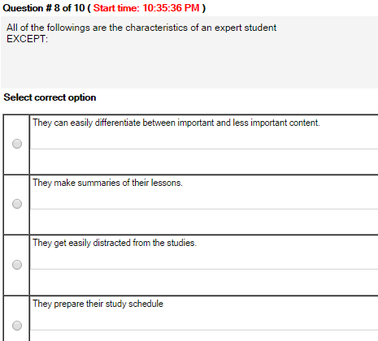

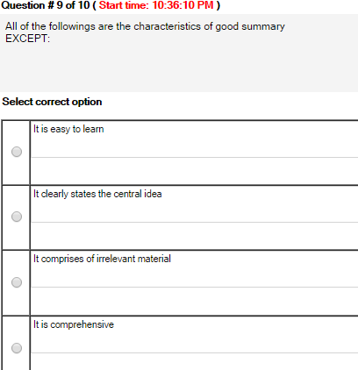
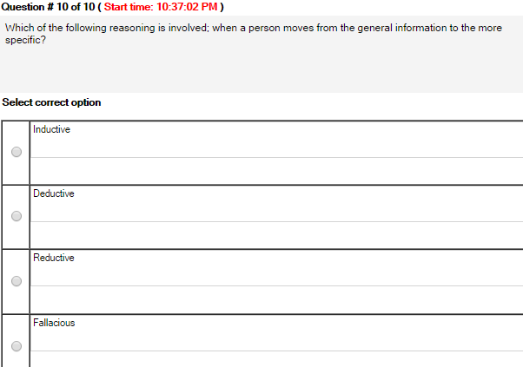
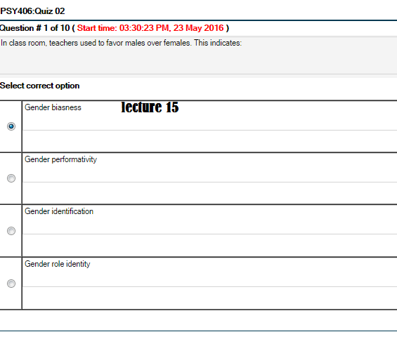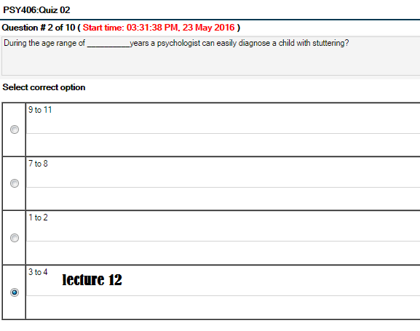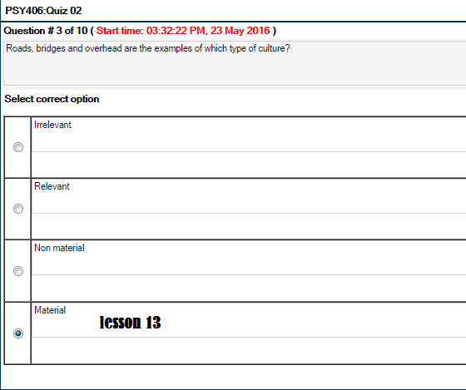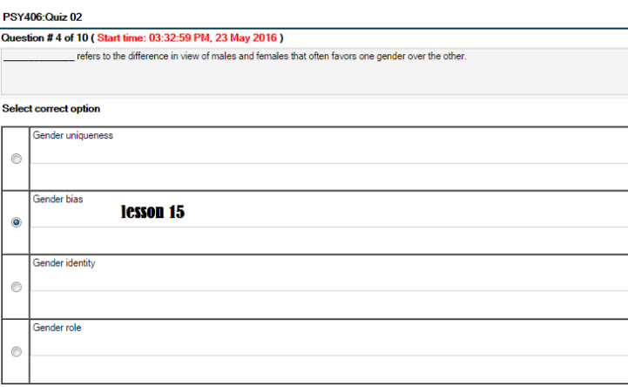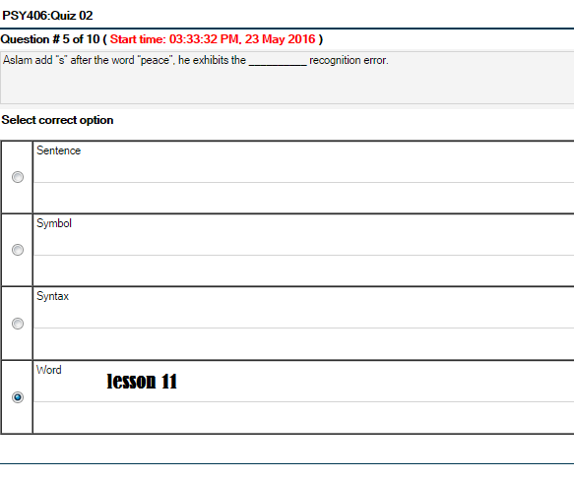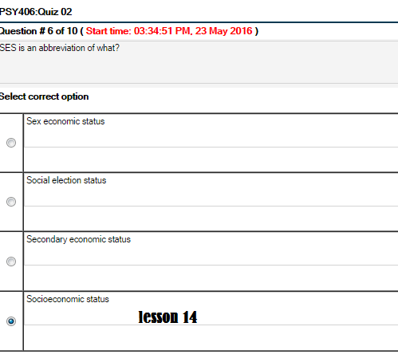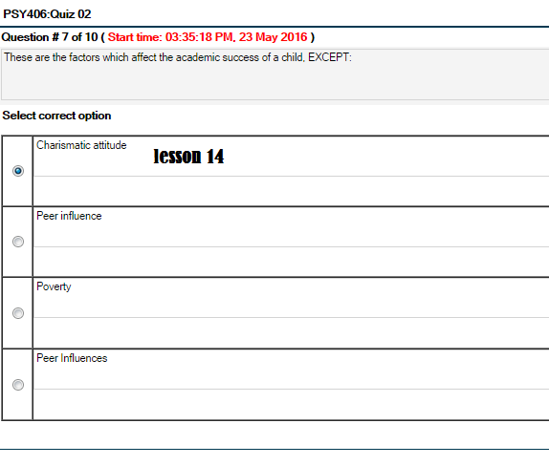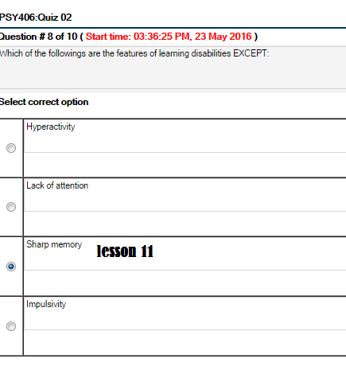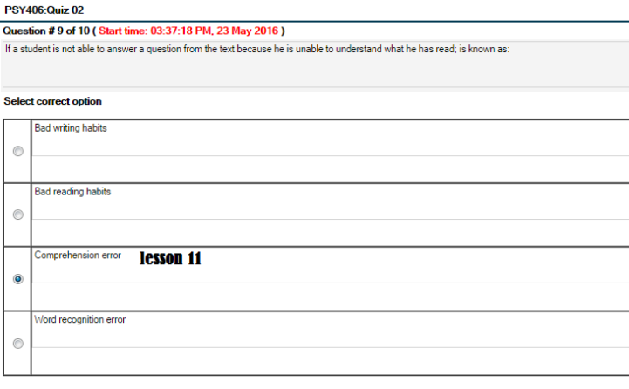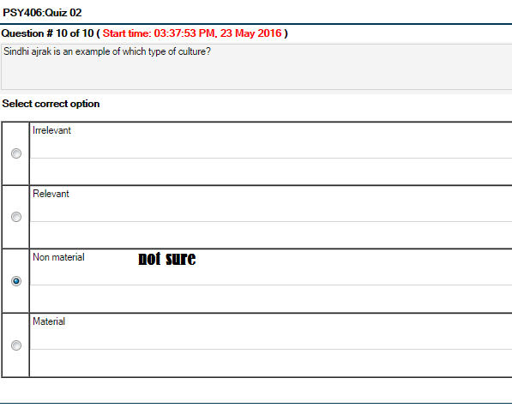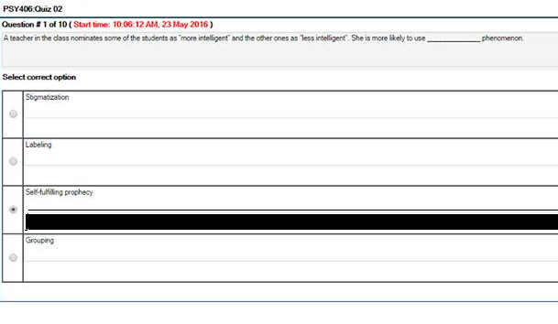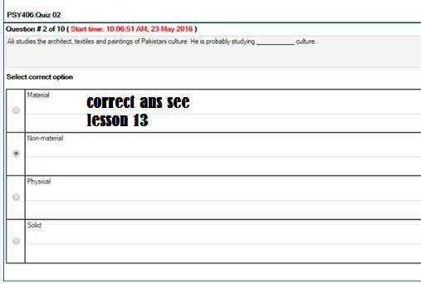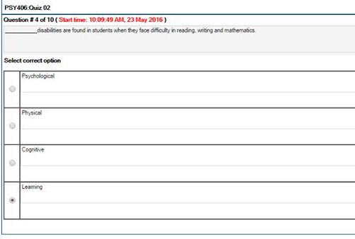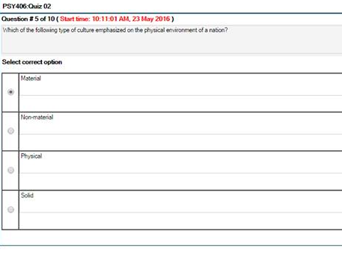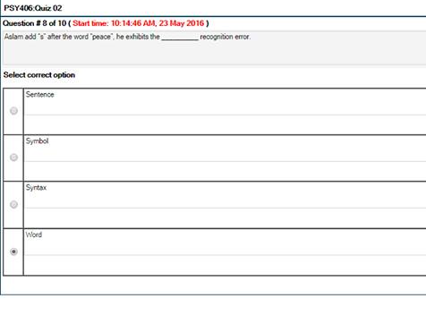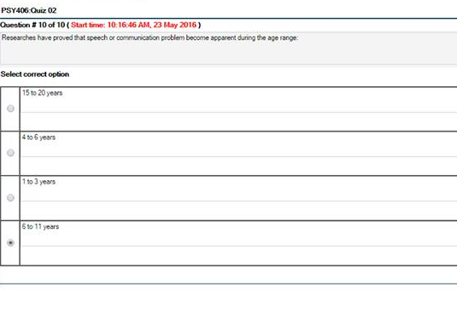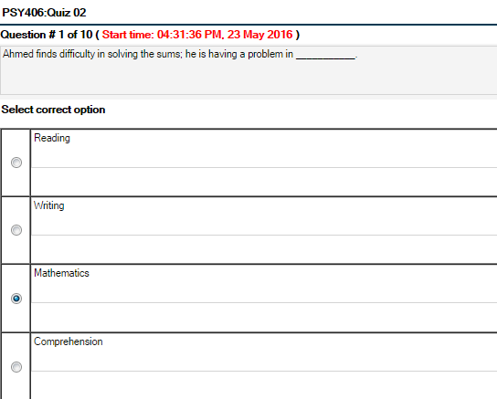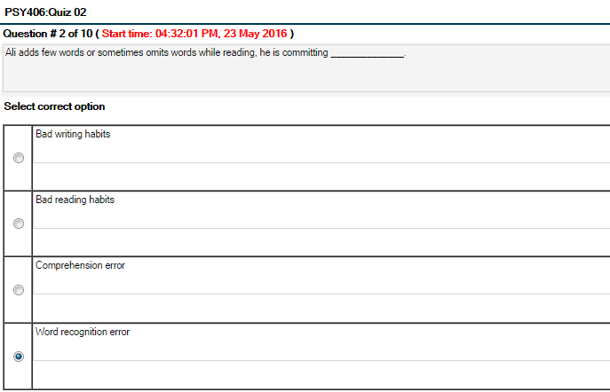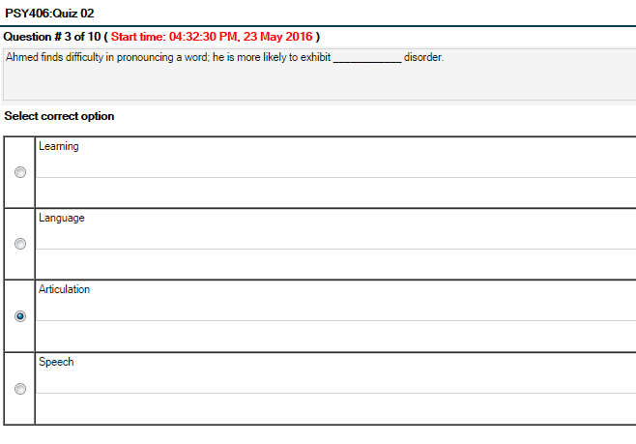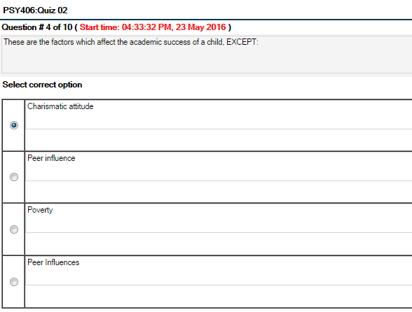
Quiz#3
Psy406-Educational Psychology Quiz 3 Lessons From 16-21
Date 20 June 2016
1:
Who purposed the social learning theory?
• Albert Bandura
• Thorndike
• Pavlov
• Skinner
2:
According to Pavlov,……is in which a neutral stimulus evokes the same response after being associated with a natural stimulus.
• Assimilation
• Association
• Conditioning
• Accommodation
3:
Which of the flowing process may help the students in understanding and remembering stories?
• Script
• Schema
• Event schema
• Story grammar
4:
Which of the following is not an important element of the vicarious learning?
• Apprehension
• Production
• Retention
• Attention
5:
Ali comes to know that his favorite restaurant will open till still 6pm. Which of the following memory may help ali to remember the opening timings?
• Semantic
• Procedural
• Declarative
• Short-term
6:
Baundra believed that human functuinig is the product of the mutual interaction of environment, person, and …….
• Behavior
• Cogntion
• Learning
• Heredity
7:
Aristotle is greek philosopher died in…..Bs.
• 338
• 339
• 322
• 323
8:
According to skinner, learning which occurs as at result of consequences of behavior is known as?
• Reflexive conditioning
• Positive condition
• Classical condition
• Operant condition
9:
In…. memory, we are able to consciously recall information and facts mathematical symbols etc.
• Semantic
• Procedural
• Declarative
• Short-term

Quiz#3 of pay406

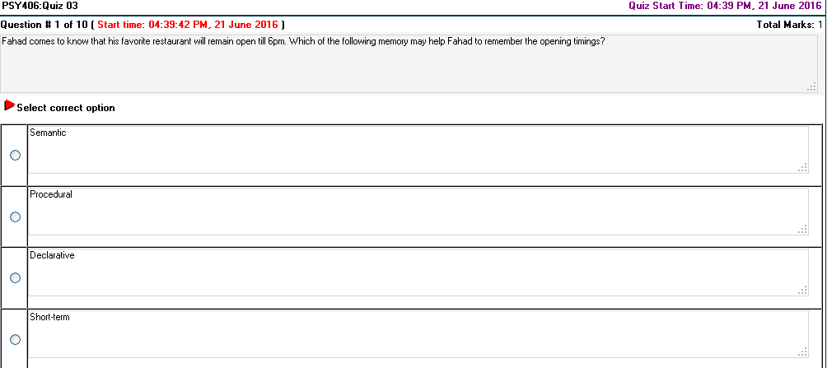
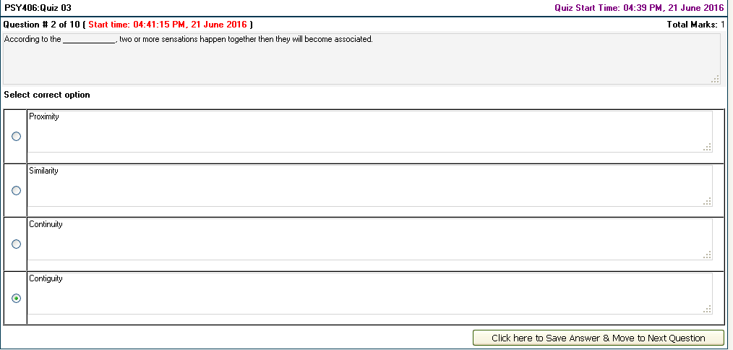
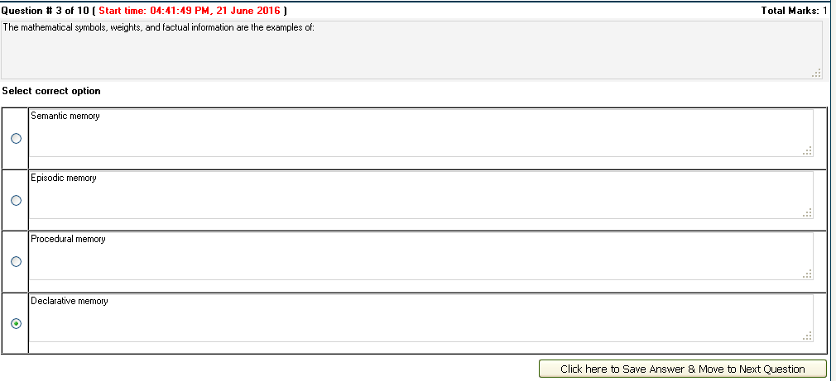
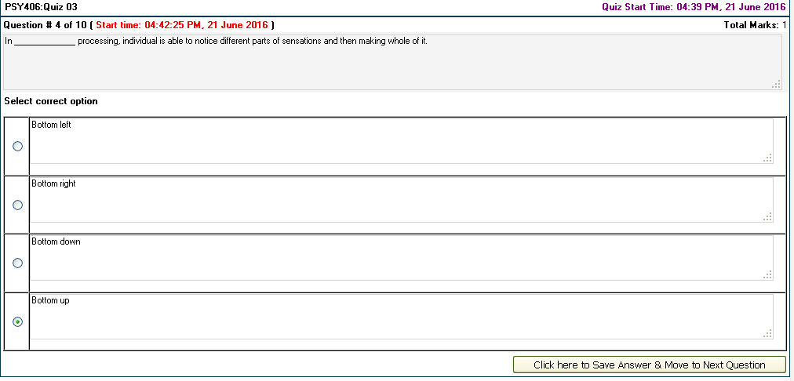
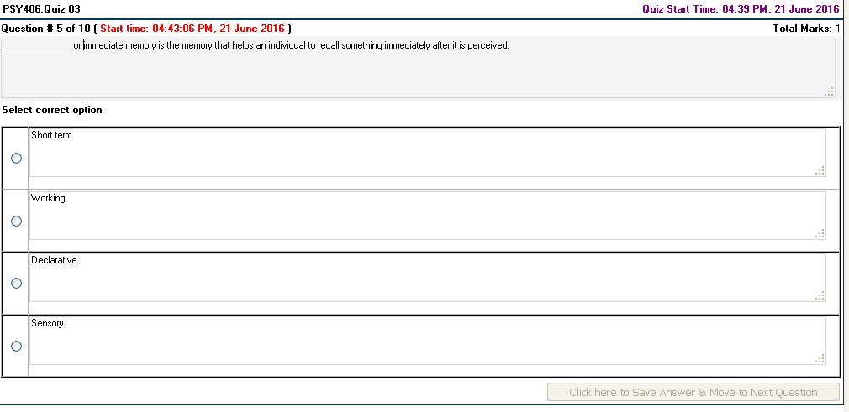
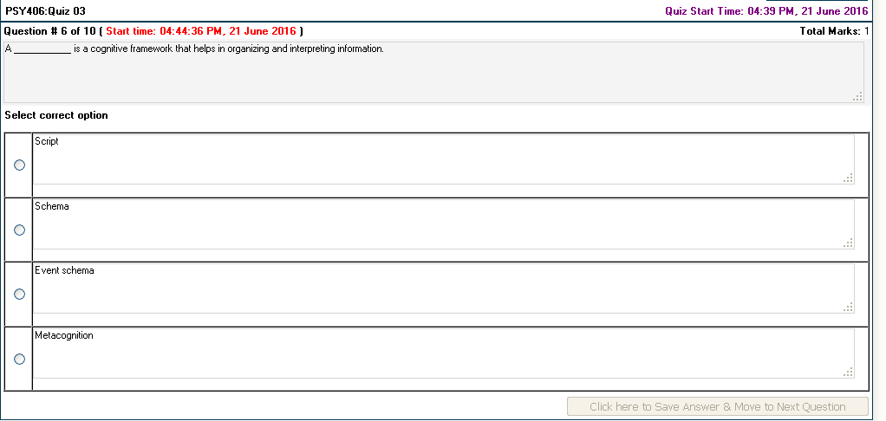
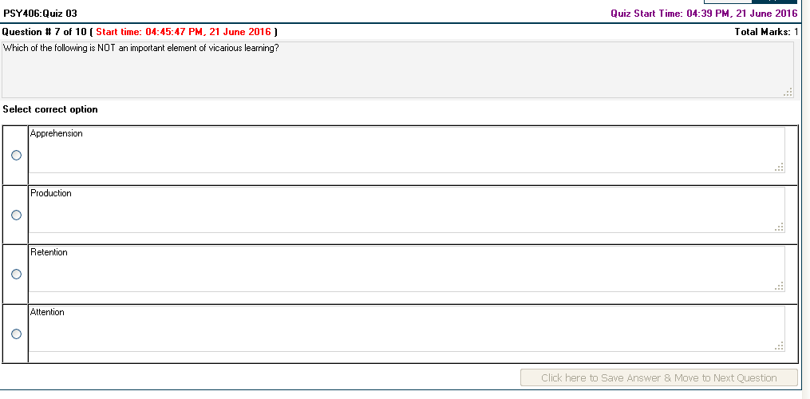
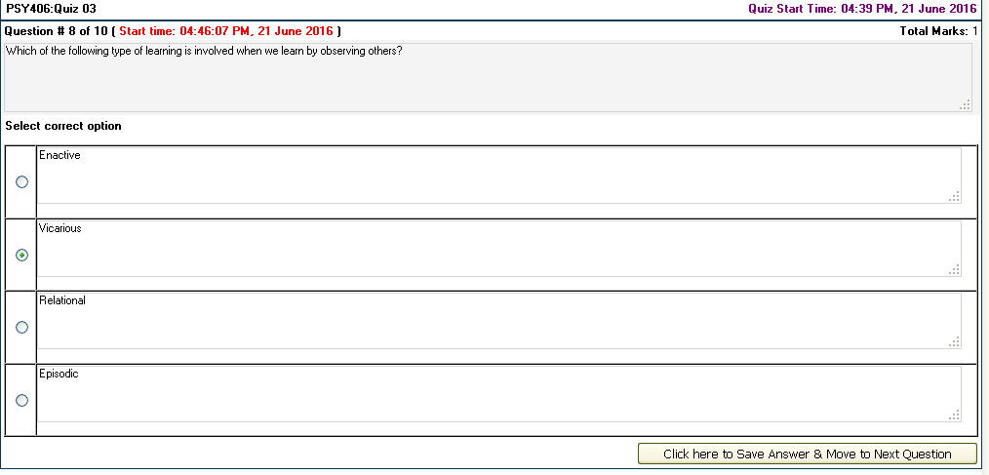
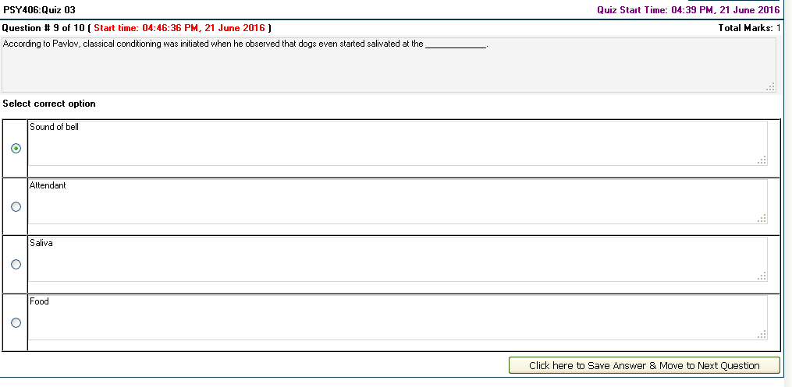
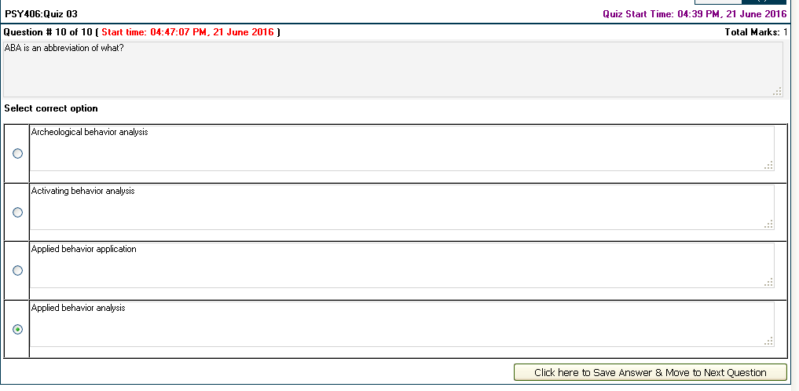

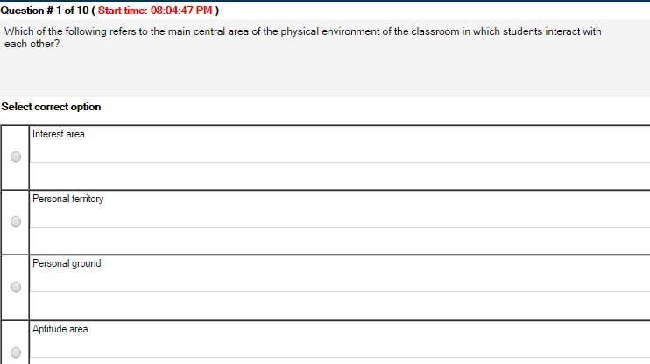
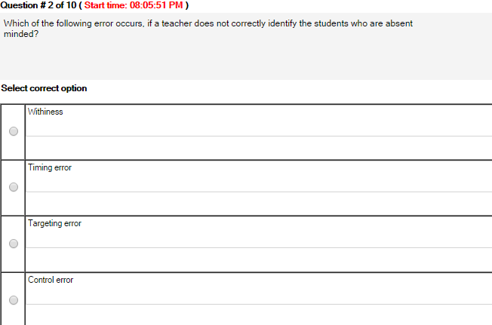

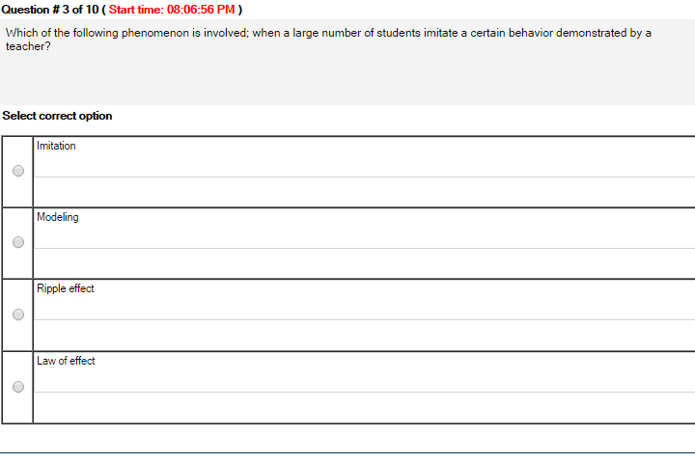
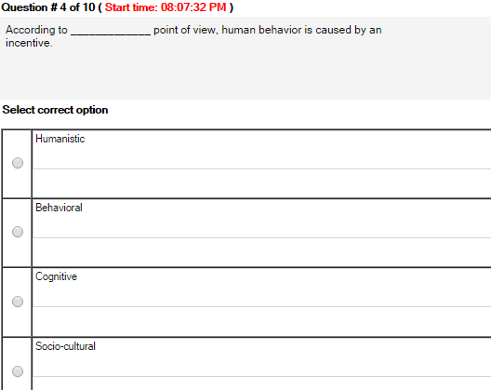

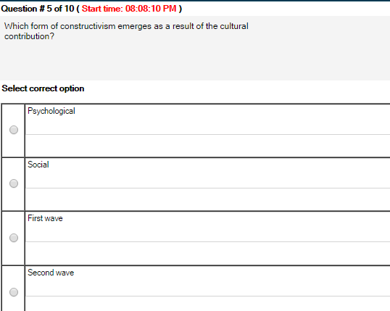
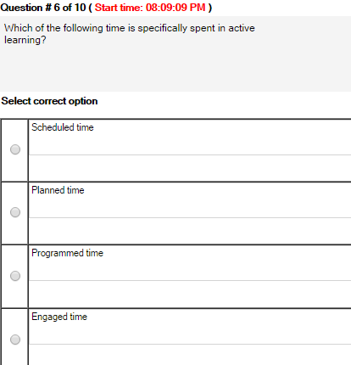
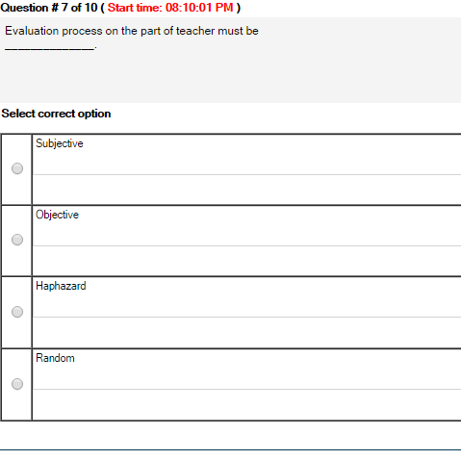
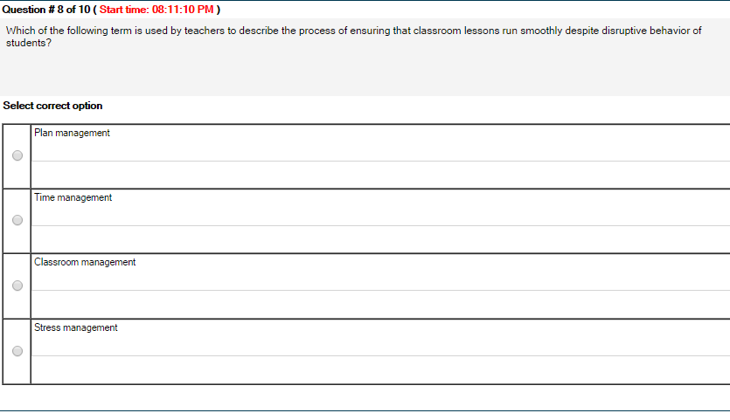

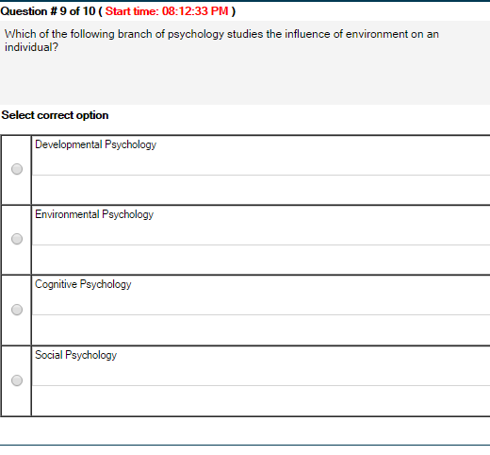
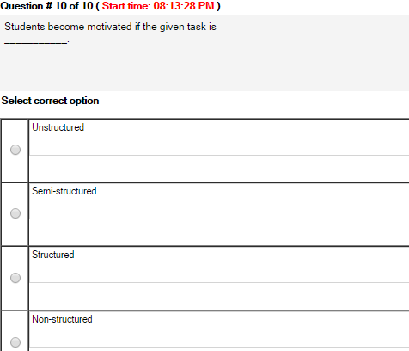
Quiz#3
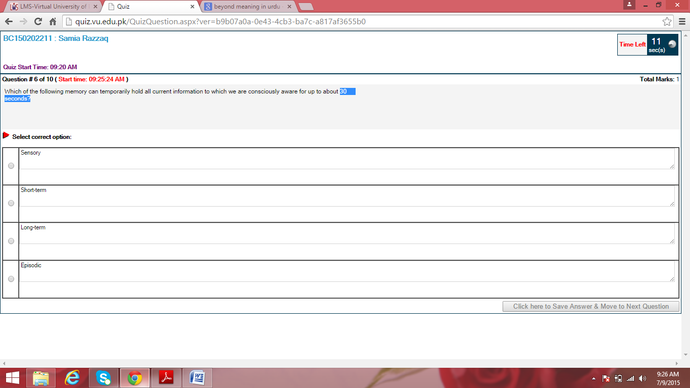

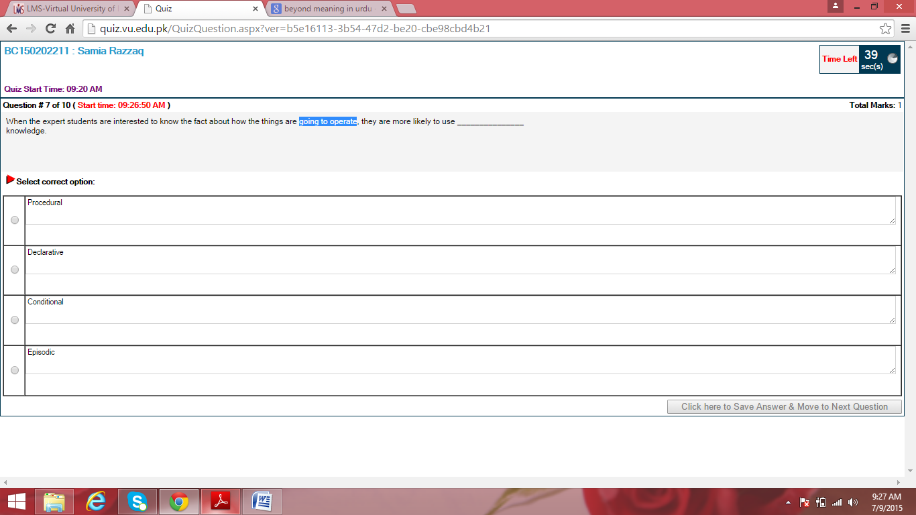

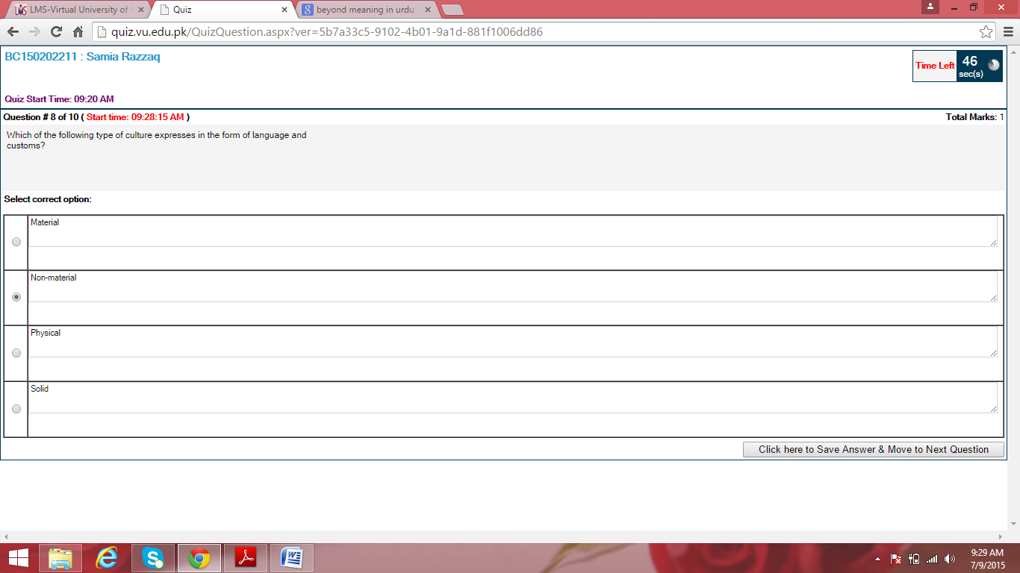

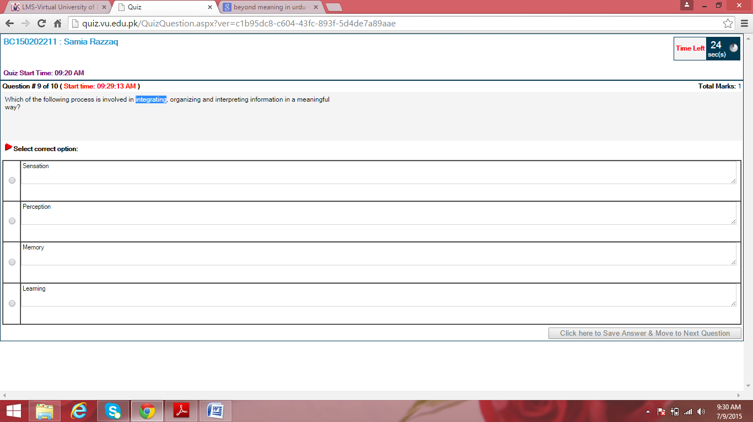

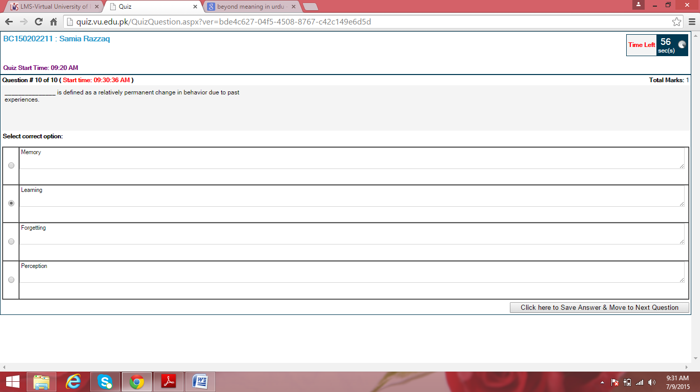

Quiz#4

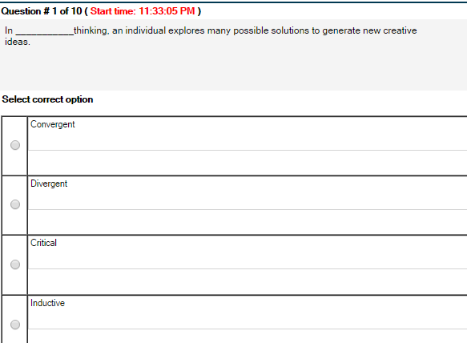
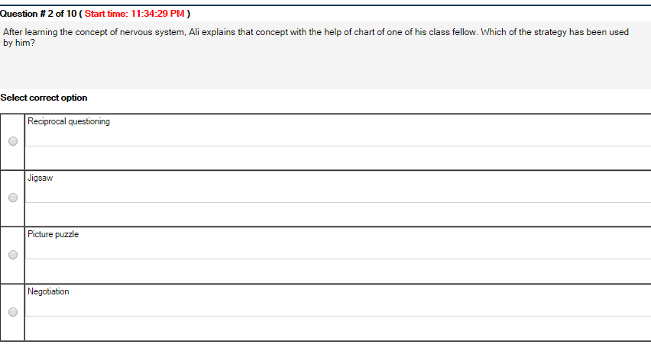
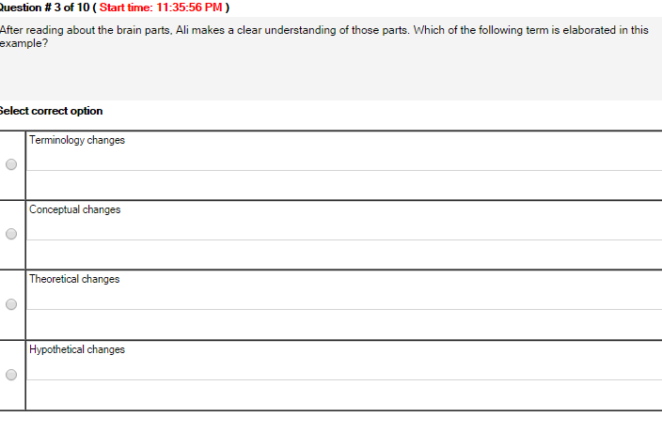
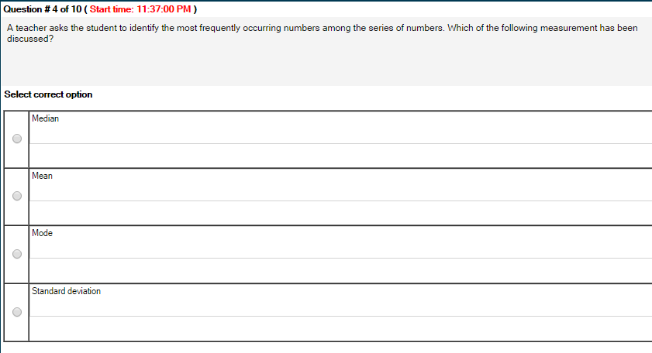
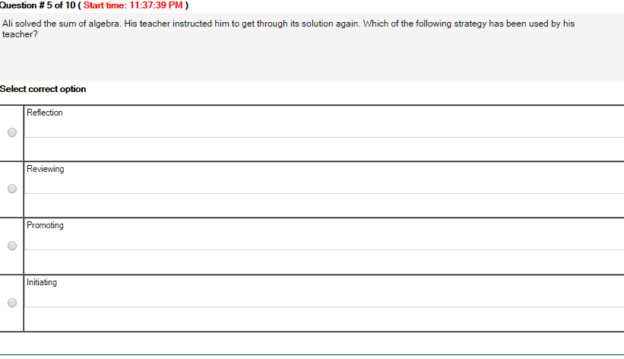
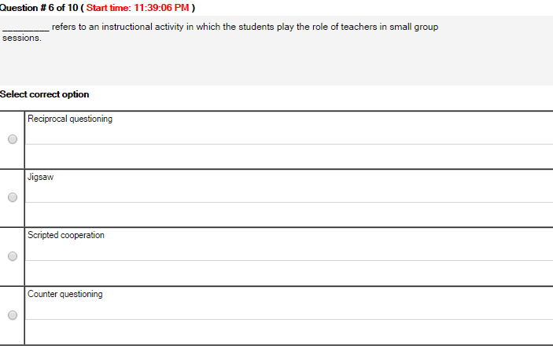
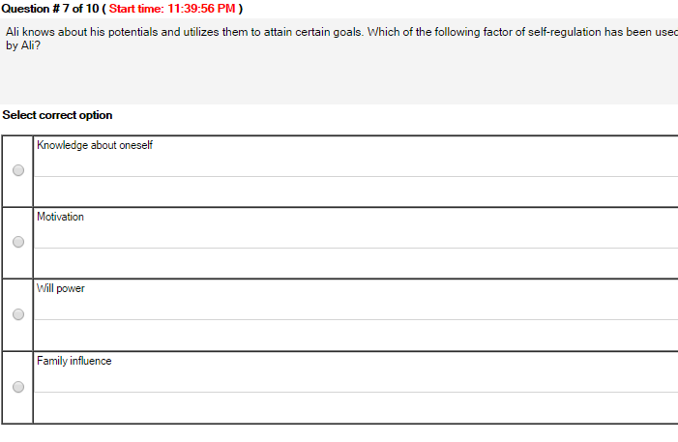
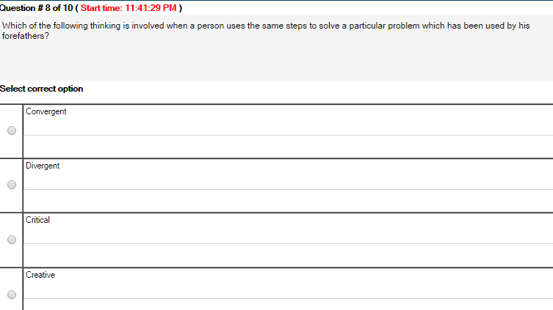
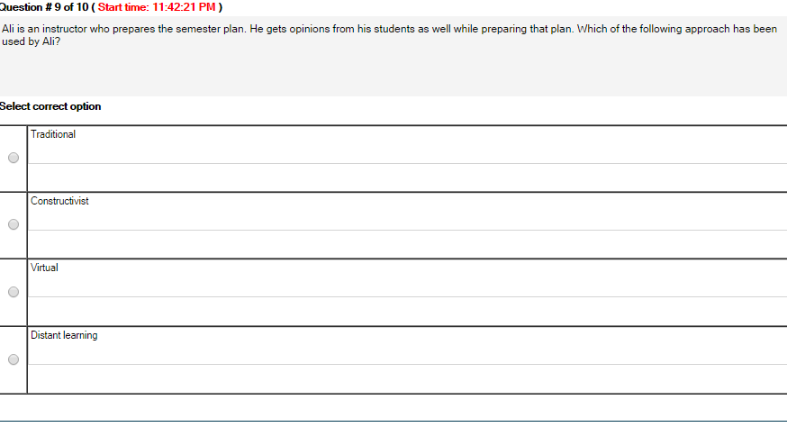
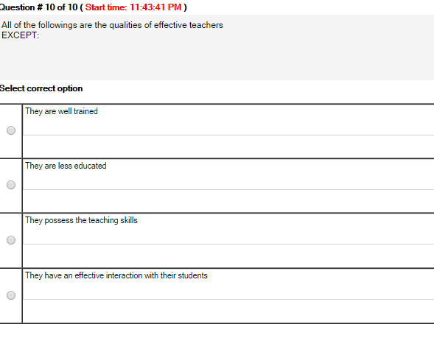

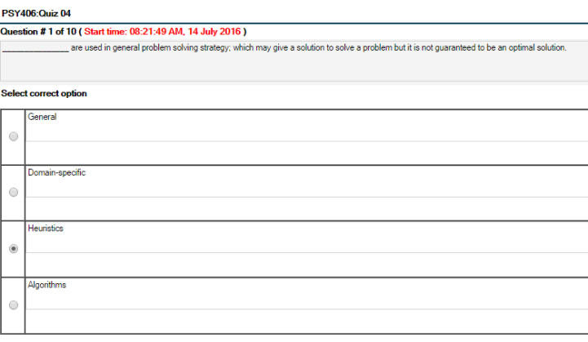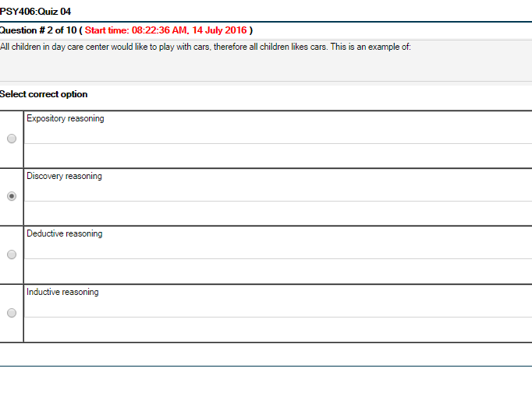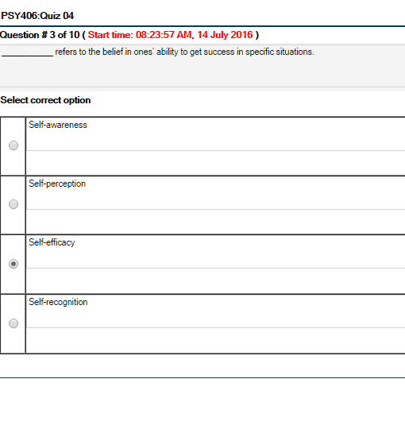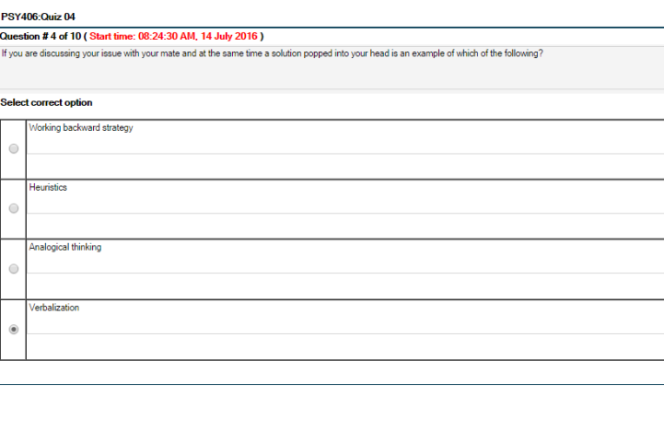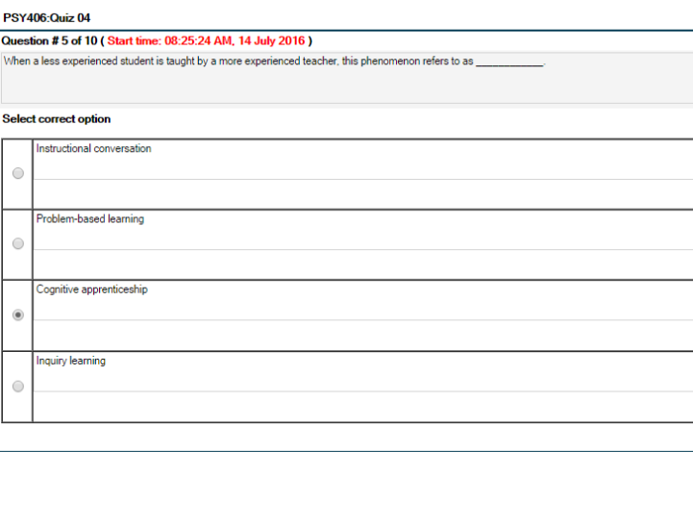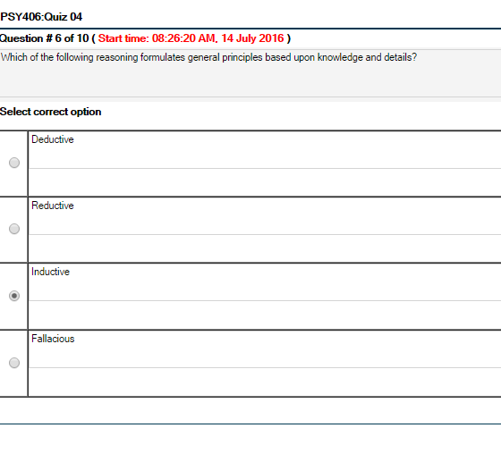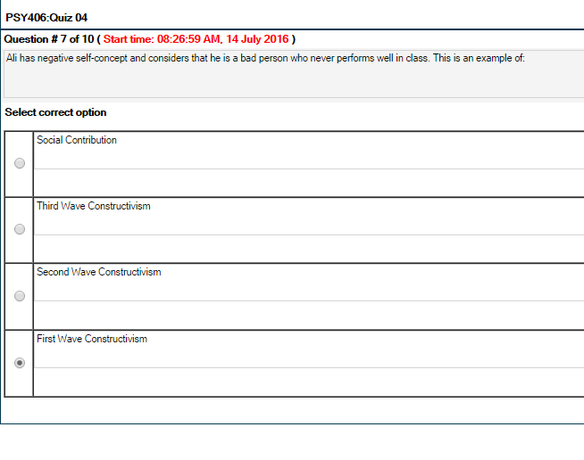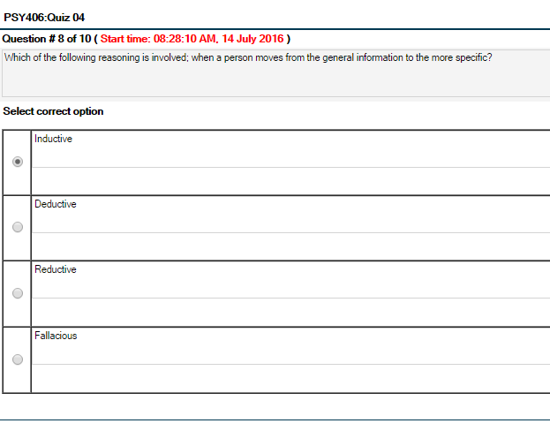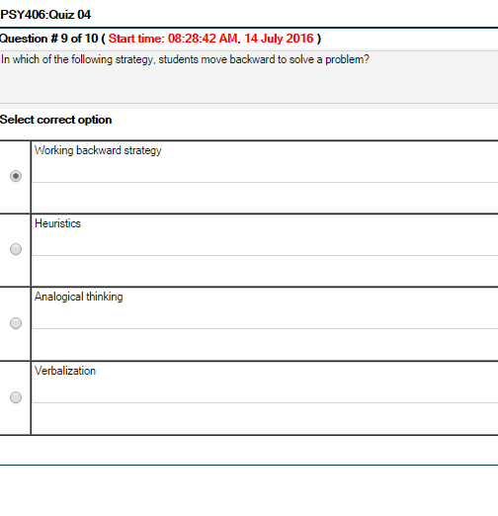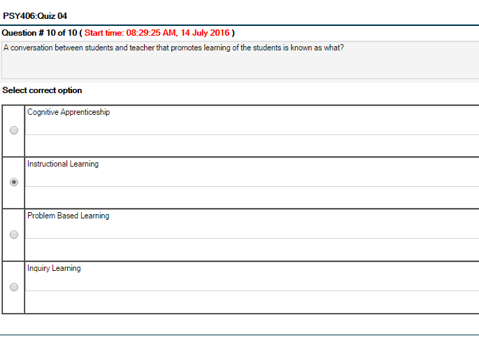

Quiz#5
Psy406 Quiz 5 My Quiz
Z score is known as what?
Median score
Percentile score
Regular score
Standard score
2:
What is meant by perceiving emotions?
Highlighting emotions
Discussing emotions
Explaining emotions
Recognizing emotions
3:
Which of the following time period is spent by a learner on learning a specific task at hand?
Planned time
Programmed time
Engaged time
Time on task
4:
In student teacher’s interaction, experts suggest all of the following for the teachers EXCEPT:
Vary seating of students from time to time
Indirect questions to all students
Establish eye contact with all students
Move around in classroom rather than stay at one place
5:
Which of the following thinking is involved when a person uses the same steps to solve a particular problem which has been used by his forefathers?
Convergent
Divergent
Critical
Creative
6:
All of the followings are the characteristics of effective teachers EXCEPT:
They are knowledgeable
They make clear presentations
They are unaware of the student’s confusion
They show warmth feelings towards students
7:
All of the followings are negative emotions EXCEPT:
Disgust
Anger
Love
Hate
8:
Which of the following education may help in developing certain positive qualities such as honesty, kindness in students?
Academic
Character
Extra-curricular
Practical
9:
In which of the following classroom area, a student displays charts on the walls of the classrooms?
Interest area
Personal territory
Personal ground
Aptitude area
10:
The score that occurs most frequently in a series of scores is known as what?
Percentile
Median
Mode
Mean

Subjective Final Term
Psy406 final term paper 2016
Psy- 406 Subjective Paper today:
1. write two types of Social learning? 2
2. Enlist three strategies of cooperation. 3
3. Do you think that our education system encourages
4. If you work hard, your grades will go up. What kind of relation this is? 2
(in this, i wrote positive co-relation)
5. what does it men by self-management, and classroom management.?
6.If you were a teacher, how would you be an effective teacher? (5)
7.Explain in your own words, what do you mean by Norm-referenced grading? (5)
8. Give 2 examples, one of each +ve halo effect and -ve halo effect.
Psy406 final term paper 2016
Psy 406 final paper
MCQ's = 40
Subjective questions = 10
Q-1 Difference between self-management and class-management? (5)
Q-2 How would you differentiate between psychological constructivism and social constructivism?(5)
Q-3 Any five important things that a teacher should keep in mind while communicating result grades to the students?(5)
Q-4 define will power? Write any event from your life when will power played a prominent role in your self-regulation?(5)
Q-5 Describe any five ways in which teacher can curtail cheating habits of their students?(5)
Q-6 How would you create a link between autonomy and motivation? (3)
Q-7 How does response set create hindrance in transference? (3)
Q-8 Which method is considered more beneficial for exams,weekly or monthly.Justify your answer with examples.(3)
Q-9 Define self-regulation? Exemplify that how do you rate your ability of self-regulation?(3)
Q-10 Amna, a two year s old baby girl wants to put her clothes on by herself.Her mother allows her to try until she succeeds or ask for assistance.In which stage of psychology develop(given by Eric Ericson) Amna is passing through. Name that stage and justify it?(3)
Psy406-Educational Psychology Final Term Paper 20 August 2016!
MCQS 40
difference b/w stigma n ,
being a teacher how u teach autistic child cross road,
how teach compession n tolerance,
how to teach word apple,
ball n hippopotamus,
motivation strategies,
how to maintain discipline in class n effective learning
Objectives comes from the topics gender bias,cognitive development and language,behavioral views of learning,portfolio, high road transfer,ripple effect,social cognitive and constructivist view of learning,evaluation process,better time management,Emotional intelligence,reciprocal questioning,mean,reliability,Action zone
My 2nd paper of Final term 2016,,,, Total 50 Question,, (40-Objectives, 10-Subjectives)
Sharing subjective part…. 5 Short questions, each carry 3 marks:
1. Debate about effective teacher, one group of psychologists believe that effective teachers born, other believe tey made, In this regard what do u believe, give own opinion?
2. Enlist factors which lead to lack of tolerance, Have u experience any of those?
3. Are u intrinsically or extrinsically motivated, explain with the example of daily life.. ?
4. An experiment was conducted to check the effectiveness of anxiety treatment, during experiment group A attained the individual therapy session and receive new medication while Group B receive Placebo, in this case Group A refers to What? Identify + briefly describe?
5. Piaget give four stages of development, Enlist any three of them? Comparatively Long Question …marks (5*5)
6. What role modeling plays in a moral development of a child, Explain with the help of two real life Examples?
7. Identify any 5 factors that facilitate social learning in individual?
8. During the process of information storage Human mind and computer perform six main functions in the same manners, Enlists any five of them in ur own words?
9. Enlist any 5 prerequisites for objective type of test construction?
10. The student will be able to draw, Multiview drawing of assigned machine parts with 90% accuracy , this is an example of which instructional objective (behavioral or cognitive) identify + justify ur slection?

Final Term 2016

Children intimate behaviour of their parents . do u agree r not. Justify ur stance with logical argument????
3. Define and explain realibality and validity with the help of example
4. Explain 2 milestone which children achieve at concrete operational stage as given by Piaget???
5. How a teacher can hold the attention of his / her students?
6. How would u differentiate b/w psychological constructivism & social constructivism???
How do u see the relationship b/w motivation & self regulation of a student????
Differentiate b/w objective testing & essay testing???
Instructionals objectives ...
engaged time....
academic learning time....
time on task....
summarizing. ...
diff b/w psychological constructivism & Social Constructivism. ..
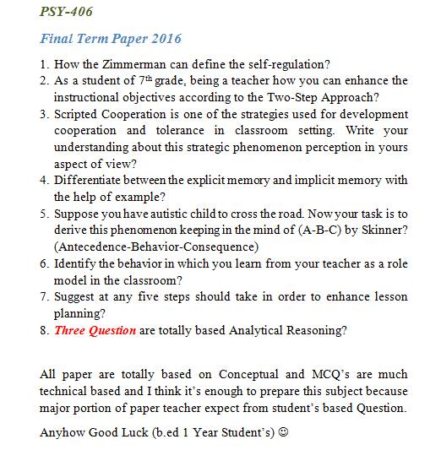
My Today's Paper! 30 August 2016!

- Question about effective teacher are born or made comment
- Problem solving strategies 2 question from this topic 10 marks
- Learning mathematics 5 marks
- Are there difference between working of grade achieving and working of learning ? Yes or no 5 marks
- Co-construction? Who give this concept?
- Providing effective,feedback strategies

Mid Term paper
Mid-Term Fall 2016
My Today's Psy-406 Paper..
22 Mcqs mix
3 Questions of 3 marks
& 2 of 5 marks
1- What do you know about demonstrating as a teaching strategy- 3
2- Write any of your personal experience when intentionally or unintentionally law of contiguity affects your behavior-3
3- How peer relationship affects our moral development-3
4- Think creatively and write at-least 5 reinforces for an elementary students-5
5- write 2 areas of research for educational psychology and identify dependent and independent variable in them-5
Mid term Paper on 29 december 2015
Total Questions=27
MCQ’S=22
Subjective questions=5
Q-1 Difference between Hostile and Instrumental Aggression.Explain with two examples each. 3 Marks
Q-2 Explain Bottom up process and Top down process with two examples of each. 5 Marks
Q-3 In an Economic System i.e explain socialism and capitalism as( Micro level or Macro level). 5 Marks
Q-4 Strategy of problem solving explain with Working backward strategy. 3 Marks
Q-5 Peer Influence. 3 Marks
MCQ,s related from following topics.
Trust verses Mistrust,Gender Bias,Self-Regulation in teaching,Teachers Qualification and training,Dependent and Independent variables,Self-concept and Self-esteem,Self-fulling Prophecy,Levels of development,Token Economy,Material and Non-material culture,Learned helplessness,Learning disabilities.

Mid Term 2016
- home environment and resource impact on student academic achievement. (5)
2. teacher strategy to handle talented students.
3. tracking influence on student academic achievement.
4. what is development crisis and how can child handle it.
Mid term 2013
Was somewhat easy. Consisted of 27 questions among which 22 were MCQs. MCQs were pretty different from those given in Quiz and assignments.

Subjective:
1. Enlist three limitations of experimental method.
2. Enlist three benefits of habit formation.
3. What happens at the 'Trust vs Mistrust' Stage? Who proposed it? (3 marks)
4. Mention the contribution of Edward Thorndike. (5 marks)
5. Zara's parents got divorced. How can the teachers help her get through this (5 marks).
Mid term 2015
Q-1 Difference between Hostile and Instrumental Aggression. Explain with two examples each. 3 Marks
Q-2 Explain Bottom up process and Top down process with two examples of each. 5 Marks
Q-4 Strategy of problem solving explain with Working backward strategy. 3 Marks
Gender biased in text ka pocha tha
vicarious or enactive ka pocha tha
Co-construction:
how perception is related to past experience?
Macro and micro level justification on capitalism and socialism.?
Speech disorders and language disorder:
Strategies of Problem Solving:
Mid term 2015
my todays paper
22mcqs mostly examples
3*3 marks
gender bias example
intelligence questions
example to choose deductive or inductive
5*2
significance of attention in vicarious learning.
trait of Masculine and feminine in pak culture.

Mid term 2012
My today's paper of PSY406 (Educational Psychology):
Total: 27 Questions
22 MCQs
3 Short Questions of 3 marks each.
1. As you are a student of educational psychology, point out the new horizons of this field.
2. What do you know about accommodation? Explain with the help of an example.
3. Narrate the implications of the theory of operant conditioning in educational settings.

2 Long questions of 5 marks each.
4. What do you know about differential method? Explain with reference to educational psychology.
5. The self-concept evolves through constant self evaluation in different situations. Write a comprehensive note on development of self concept.

Psy 406 mid term 07 june 2016!

1. Amna and her sister are playing. Amna is pretending to be a doctor and her sister patient.. what Piaget's stages they both attained explain answer with justification?
2. Aslam is the student who doesn't play with his class fellows during break time, as the student of educational psychology prepare a plan to shaping his behaviour?
3. Difference between instrumental aggression and hostile aggression?
4. Labeling the students?
5. Difference between Enactive learning a Vicarious learning?

Mid term 2015
paper 1:

My PSY 406 (Educational Psy) Paper.
total 27 Qs, 22 mcq,
all paper was conceptual
, Eric Ericson ki eight stages important hain
, mcq aur subjective mein b ai hui thi.
memory waly topic,
special children learning
, sensory memory
, Kohlberg theory se bhe mcq thy.
Self-fulfilling Prophecy se aik question tha.
Gender bias ka mcq tha.
mathematical formula yad kerna kon c memory hai, mcq bhe tha aur subjective question mein b tha.
paper 2:
Today paper of psy406
27 ques total
22 mcqs and 5 subjective ques
1.learned helplessness
2.difference between cultural diversity and cultural compatibility
3.stigmatation
4.top-down processsing
5.verbalization
paper 3:
Psy406 today paper
Total 27 questions
22 mcqs and 5 question
1.Verbalization
2.top-down processing
3.cultural diversity and cultural compatibility didderence
4.define stigmatation
5.learned helplessness
paper 4:
my today psy406 paper
total qus=27
objective 22
subjective 5
meterial n non-meteria k kafi qus thy qustn mn b n objectv mn aggression n assertive mn dfrnc culture diversty n culture compatiblety mn dfrnc non meterial ki example dyni the punjabi n sindhi culture dfrnce mn koi ak behvior modl btana tha jo ap nay past sy sekha ho bot ajeb sa paper tha ovrall objectv mid k lacture say tha shyd q k mn nay end k n strt k lacture kiya thy un mn say kuch nai aya tha..

Psy406-Educational Psychology my mid term paper 08 june 2016

Total questions 27:
MCQS=22
Subjective= 5
Mcqs based on the real life examples ...
Questions
1 question is from Erickson stage justification
* stigma and Self-fulling Prophecy 3 marks
*Enactive learning and vicarious learning?5
*self regulation resources?
speech problems cause?

Psy-406 Educational Psychology Current and past midterm papers 2015& 2016
Psy-406 Current mid Term paper (Paper 1)
30 may 2016
Total Questions = 27 Total MCQS =22

Factors that influence academic achievement and in context of Pakistan?
2.
Speech problems?
3:
Gender bias examples in Pakistan?
4:
Stigma and self fulfilling prophecy?
…………………………………………………………………………………………………………………
PSY406 Educational Psychology mid Term paper 02 June 2016! (Paper 2)
1:
Material culture and non material culture?
2:
macro and micro culture?
3:
kholbhug. Stages of morality?
4:
development.
Or crikson or pieget stages?
5:
orderly, continues and gradual development?
6:
hostile aggression with real life example,
3:
Intelligence and with logic k intelligence inherited hote he ya acquire ki jati he,
4
Dialect and bilingualism,
5
Who are those students who take benefit from token economy?
……………………………………………………………………..
Psy 406 midterm 2015 (Paper 3)
22mcqs mostly examples
3*3 marks
1:
Gender bias example?
2:
Intelligence questions?
3:
Example to choose deductive or inductive?

5*2
4:
Significance of attention in vicarious learning.
5:
Trait of Masculine and feminine in pak culture.
………………………………………………………………………..
Psy406 midterm past paper (paper 4)
Total Questions =27
22 MCQ'S
5 Subjective Questions
1. Scope of Educational psychology?
2. Development of self concept?
3. Contribution of educational psychology in learning and teaching methods?
4. Trans-personal psychology?
5. Peer culture?
……………………………………………..
PSy-406 Educational Psychology mid Term paper 03 June 2016 (paper 5)
22 mcqs: - most mcqs were conceptual
5 subjective questions
1. Slurred speech is a learning disability. Describe briefly? (3)
2. Describe the forms of negative label? Explain with the examples? (3)
3. Think for a while and describe when you have intentionally or unintentionally use the law of continuity? (5)
4. Ali is an education psychologist; he thinks that the continuous reinforcement schedule is best to be applied to teach an autistic child about table manners. Do you agree with this idea or not explain logically? (5)
……………………………………………………………………………..
PSy-406 Educational Psychology mid Term paper December 21, 2015 (Paper 6)
- Eric Erickson of 2nd stage?
- Slurred speech?
- Long term memory or short term?
- Gender biased in text?
- Vicarious or enactive?

………………………………………………………………..
PSy-406 Educational Psychology mid Term paper December 22, 2015 (Paper 7)
22 mcqs
And 5 subjective questions
Detailed questions:
- co-construction
- , peer pressure related to bad academic achievement explain with example,
- token economy is used on what kind of students,
- how perception is related to past experience,
- mcqs two were related to correlation,
- two were related to dependent and independent variable,
- one related to meta cognition,
……………………………………………………………………………
PSy-406 Educational Psychology mid Term paper December 22, 2015 (Paper 8)
- Vicarious Learning
- Self talk
- Strategies of problem solving
- Macro and micro level justification on capitalism and socialism.
- Speech disorders and language disorder.
…………………………………………………………………………….
PSy-406 Educational Psychology mid Term paper 29 Dec 2015 (Paper 9)
Total Questions=27
MCQ’S=22
Subjective questions=5
Q-1 Difference between Hostile and Instrumental Aggression. Explain with two examples each. 3 Marks
Q-2 Explain Bottom up process and Top down process with two examples of each. 5 Marks
Q-3 in an Economic System i.e. explains socialism and capitalism as (Micro level or Macro level). 5 Marks
Q-4 Strategy of problem solving explains with working backward strategy. 3 Marks
Q-5 Peer Influence. 3 Marks
MCQ, s related from following topics.
Trust verses Mistrust,
Gender Bias,
Self-Regulation in teaching,
Teachers Qualification and training
, Dependent and Independent variables,
Self-concept and Self-esteem,
Self-fulling Prophecy
, Levels of development,
Token Economy,
Material and Non-material culture,
Learned helplessness,
Learning disabilities.
…………………………………………………
Psy-406 Educational Psychology mid Term paper 28 Dec 2013 (paper 10)

Consisted of 27 questions among which 22 were MCQs. MCQs were pretty different from those given in Quiz and assignments.
Subjective:
1. Enlist three limitations of experimental method.
2. Enlist three benefits of habit formation.
3. What happens at the 'Trust vs. Mistrust' Stage? Who proposed it? (3 marks)
4. Mention the contribution of Edward Thorndike. (5 marks)
5. Zara's parents got divorced. How can the teachers help her get through this (5 marks).
…………………………………………………………..
Psy-406 Educational Psychology mid Term paper 28 May 2016 (paper 11)
1. Home environment and resource impact on student academic achievement. (5)
2. Teacher strategy to handle talented students.
3. Tracking influence on student academic achievement.
4. What is development crisis and how can child handle it.
……………………………………………………….

Psy 406
Final Term papers
Paper 1:
Total Questions 50
MCQS 40
Subjective Questions : 10

- modeling
- self regulation
- helplessness
paper 2:
February 28, 2016
- Difference btw achieving grades and working to learn
- Evaluation process
- Over learning
- Skinner behaviour theory
- Locus of control
- Effective feedback
- Learning strategies
- Non- materialistic culture
- Emotional intelligence
Paper 3:
February 28, 2016
Psy 406 final paper
MCQ's = 40
Subjective questions = 10
Q-1 Difference between self-management and class-management? (5)
Q-2 How would you differentiate between psychological constructivism and social constructivism?(5)
Q-3 Any five important things that a teacher should keep in mind while communicating result grades to the students?(5)
Q-4 define will power? Write any event from your life when will power played a prominent role in your self-regulation?(5)
Q-5 Describe any five ways in which teacher can curtail cheating habits of their students?(5)
Q-6 How would you create a link between autonomy and motivation? (3)
Q-7 How does response set create hindrance in transference? (3)
Q-8 Which method is considered more beneficial for exams,weekly or monthly.Justify your answer with examples.(3)
Q-9 Define self-regulation? Exemplify that how do you rate your ability of self-regulation?(3)
Q-10 Amna, a two year s old baby girl wants to put her clothes on by herself.Her mother allows her to try until she succeeds or ask for assistance.In which stage of psychology develop(given by Eric Ericson) Amna is passing through. Name that stage and justify it?(3)
Paper 4:
February 29, 2016
- Objectives comes from the topics
- gender bias
- ,cognitive development and language,behavioral views of learning
- portfolio,
- high road transfer
- ,ripple effect,
- social cognitive and constructivist view of learning,
- evaluation process
- ,better time management
- ,Emotional intelligence,
- reciprocal questioning,mean,reliability,
- Action zone
Paper 5:
March 4, 2016
total 50
10 questions
1-fear of failure affects our motivation discuss in context to pakistani society.
2-Humanistic approach about motivation.
3-reviewing in learning of mathematics.
4-central tendency type and explain.
5-kohlburg conventional reasoning
6-emotional intelligence qualities.
7-modeling
8-first wave of constructivism
9-functional fixedness.
10-over learning.
Paper 6:
Final Paper Educational Psychology PSY 406: 27th Aug 2015
Total question = 50
MCQs =40
Subjective question = 10 ( All 5 marks' question was indirect not simple )
1. differentiate continuous reinforcement and inttement reinforcement
2.Modeling
3. Any strategy who develop compassion and tolerance in class? ( jigsaw)
4. define Task nature?
5. three benefits of planning in class?
6. Influence of "knowledge" on self regulation?
7. what you learn from your school and what were your experience of teaching? ( may be from effective teaching)
8. jocub kounin 's contribution? ( classroom management)
9. Meaning based learning and sound base learning and which is usefull in teaching English?
Paper 7:
August 29, 2015 at 12:06pm
PSY406 Current Paper
40mcqs
1- Define self-regulataion. How do u rate ur ability of self-regulation? (3)
2- Explain withiness. (3)
3- Three ways to measure central tendency. Name and define. (3)
4- Are you extrinsically motivated or intrinsically motivated? Give example. (3)
5- Three kind of students that are motivated from token economy. (3)
6- Why it is important to manage emotions? (5)
7- Cognitive apprenticeship ? (5)
8- Language is part of materialistic or non-materialistic culture? Select and explain? (5)
9- Which positive qualities did u learn from school and how did they inculated in their personality? (5)
10- Action zone and its significance? (5)
Paper 8:

My paper Psy406 midterm paper
solved 2016
How would you differentiate between continuous reinforcement and
remittent reinforcement?
Continuous reinforcement schedule
is operative when a reinforcer is presented after every appropriate response.
That is one way in which learns.
The second is called
intermittent reinforcement schedule
, when reinforcement is presented intermittently, at
some responses only

Enlist seven step plan used to tackle students
1.
Develop a signal that tells students to stop doing what they are doing and focus on you as a teacher.
2.
Avoid behavior that may distract your students, self-touching and grooming etc.
3.
Make your presentation/talk/lecture clear for students.
4.
Include variety and surprise in your talk/lecture.
5.
Asking questions of the students frequently during your talk.
6
.In teaching, you will have to ensure students’ attention to the critical features of the lesson by making clear
presentations and highlighting important points.
7.
Don’t give bad words to them

Architect Mughal era is an example of which type culture?

Material Culture
Material culture may be manifest in a nation’s or group’s architecture, the physical environment, the ways
the roads, bridges, overhead, under head passes, are made the way foot paths, highways, open spaces,
Gardens are made are all examples of material culture of a city. Some years ago some friends from abroad
had come to Lahore visiting, when they were taken around the city, one of them made a remark about
Lahore; she said she found Lahore to be like a beautiful girl who is in deep slumber. The architectural
Material culture of Lahore to a foreigner appeared to resemble a sleep beauty. So the architectural martial
Culture has a dynamic identity.

One of the three principles is development orderly
development? What do you know about?

That development is generally orderly, that development takes in an orderly path: for example, children first
sit, then develop an ability to stand and then to walk etc.

Few teacher exhibit gender biases how can it eliminate?

The first step in that direction is to accept that tendency towards gender bias. Research
Shows that teachers pay more attention and demand more input from their male students
than from their female students.
2. Teachers, after becoming aware of this tendency, must consciously curb and correct this tendency in their
classroom practices.

Psy406 final term paper solved

Ali will able draw all parts of machine with high accuracy identify which type instructional learning (behavior or cognitive learning) 5

Behavioral Objectives or learning

Behavioral objectives are lists of acts or behavior that students are supposed to show at the end of instructions. Behavioral objectives are instructional objectives stated in terms of observable behaviors or acts. For example students can draw a triangle or a square with a pencil on a plain paper

Differentiate between algorithms and heuristics (5)

Algorithm is a step by step procedure for solving a problem. Algorithm is usually used in domain-specific, which is in a particular subject area. In solving a problem, if you choose an appropriate algorithm and implement it properly, a right answer is guaranteed. Unfortunately, students often apply algorithms haphazardly. They try first this, then that. They may even happen on the right answer, but not understand how they found it. For some students, applying algorithms haphazardly could be an indication that formal operational thinking and the ability to work through a set of possibilities systematically, as described by Piaget, is not yet developed. Many problems cannot be solved by algorithms. What then? Heuristics are some general strategies used in attempting to solve a problem. Heuristics may

be attempted in general problem solving strategies.

What is different between percentile score and standard score? (5)

Percentile rank scores:

Another meaningful number in a set of large measurements is the percentile rank. Percentile rank is the percentage of those in a given sample who score at, or below an individual’s score. A percentile rank of 50, for example means that a student has scored as much or better than 50% of students in a group or a class. Similarly a percentile rank of 90% means a student has scored as much or better 90% students in a group.
Standard scores:

Another useful concept in this context is that of standard scores, these are the scores based upon standard deviation. A very common standard score is called the z score. A z score tells us how many standard deviations above or below the average, any given raw score is placed. Because it is often inconvenient to use negative numbers, other standard scores have been devised to eliminate this difficulty. A T score is the standard score with a mean of 50 and a standard deviation of 10. Thus a T score of 50 indicates average performance. And last useful concept in this regard is the concept of stanine scores. This name comes from “standard nine”. Stanine scores are the whole number scores, form one to nine, each number representing a wide range of raw scores. So these can help to categorize a given set of scores into different categories. Each stanine score represents a wide range of raw score thus making categorization of score easy, making teachers and students view another student’s score, in more general terms. We talked about mean, mode, median and standard deviation in relation to student’s scores. These calculations not only help categorizing a student on the basis of his scores but also help in giving a single, clear description of a group of students. Percentile ranks, Z score, T score, and stanine score make comparisons among students score more easy
and meaningful.

Suppose you are teacher of fifth class and give lecture on planets within 1 hour which time management technique you would use? 5

Time on task:

You may also become familiar with what educational psychologists call “time on task”, this is the time period that is spent on actively engaged in learning a specific task at hand. Time spent on various ways in learning may or may not lead to real learning. Thus academic learning time refers to the time students spend on really learning and understanding. One research undertaken by Weinstein and Mignano shows that of the one thousand and one hundred hours of class time, about one thousand are spent on attended time; about five hundred are spent on actual academic time, about four hundred hours are spent on engaged time and about only three hundred hours are spent on academic learning time, when students actually succeed in learning a task. Class management in possible and improves when school and class rules and producers are clearly stated by administration. And when these procedures and rules are conveyed to students and are understood by them. This is western countries; research, in Pakistan it has observed that less than the mentioned time is spend in our schools for learning. In this regard, Weinstein and Mignano, important researchers in the field of education, have suggested the following strategies to improve learning and motivation: a) Administrative routine, such as when and how attendance will be

taken who shall be the monitor of the class etc. b) Student movement, how and when students, may enter of leave the classroom. c) Housekeeping, how and where personal items of students will be stored. d) Routine for accomplishing lessons how the homework assignments be collected and returned. e) Routine for interaction between students and teacher will be clearly spelled out and explained to students. f) Procedures for talk between

students should be clearly explained.

What is dialectic and bilingualism? 5

Dialects
A dialect is a language variation spoken by a particular ethnic, social or regional group and is an element of the group’s collective identity. The rules for a language define how words should be pronounced, how meaning should be expressed and the ways the basic parts of speech should be put together to form sentences. Dialects appear to differ in their rules in these areas, but it is important to remember that these differences are not errors. Each dialect within a language is just as logical, complex and rule governed as the standard form of the language (often called standard speech). These facts have a profound effect on the educational process as whole. Our students across Pakistan speak different languages and within each language they have different dialects.

Bilingualism
A large majority of our school going children are bilingual, learning, speaking and reading in at least two languages, namely Urdu and English. Being bilingual puts extra burden on the learning capacity of a student.
It takes greater attention and input to achieve and maintain bilingualism. Pakistan can be proud of having and fostering different cultural units in its borders. But having differences in cultural units can also create ethnic prejudice. One ethnic group may consider it superior and impose its superiority on others

Do you think self-regulation change attitude of students towards learning? 3

Another important consideration in this regard is the contribution of another psychologist, by the name of
Barry Zimmerman. He put forward the concept of self-regulation and its relationships with learning. Self-regulation according to Zimmerman is how we activate and sustain our thoughts behaviors and emotions and these factors influence our learning. Self-regulation is the outcome of, or related to number of factors.

These factors include One’s knowledge One’s level of motivation

One’s volition or will power

One’s family influences, the influence of parents and elders etc.

An important dimension of self-regulation is that it must be carried out by individuals voluntarily and may not be imposed by fear of punishment. Voluntary self-regulation comes about, research shows from at least three sources.

Which strategy do you best for weekly and monthly test? 3

Multiple Choice Tests
Multiple choice tests can assess not only recall or recognition, but they also require a student to apply what
He/she has learned. When writing a multiple choice test the aim of the teacher is to measure a student’s achievement, and not his test taking or guessing skills.

What is the difference between allocating and engage time? 3

Allocated time: One way to better time management is estimating the amount actually spent on learning. This is called allocated time. Allocated time is the time period that a teacher sets aside for learning. Engaged time: Then there is engaged time; this refers to the time period specifically spent in actively learning.

How can teacher stop gender bias in class room? 3

The first step in that direction is to accept that tendency towards gender bias. Research shows that teachers pay more attention and demand more input from their male students than from their female students.
2. Teachers, after becoming aware of this tendency, must consciously curb and correct this tendency in their classroom practices

Suppose you read an article about dresses and now after reading this article you mostly wear very fashionable dressed after some years? Identify which type of memory is used in article

Implicit memory as part of long term memory is the memory that we are not conscious of recalling but affects our behavior or thoughts without our awareness. For example a person being a male or a female is not consciously recalled but it influences the way he or she dresses etc. From the point of view of an educational psychologist and a teacher if a teacher knows these parts and compartments of memory, he/she would be in a better position to gain, store and then retrieve knowledge and information.

